

2019 Air Quality Annual Status Report (ASR)

In fulfilment of Part IV of the

Environment Act 1995

Local Air Quality Management

June 2019

|  |  |
| --- | --- |
| Local Authority Officer | Tony Cawthorne |
| Department | Environmental Health |
| Address | Council Offices,  Bushloe House  Station Road,  Wigston,  Leicestershire,  LE18 2DR |
| Telephone | 0116 2572670 |
| E-mail | tony.cawthorne@oadby-wigston.gov.uk |
| Report Reference number | OWBC ASR 2019 |
| Date | June 2019 |

# Executive Summary: Air Quality in Our Area

## Air Quality in Oadby and Wigston Borough Council

Air pollution is associated with a number of adverse health impacts. It is recognised as a contributing factor in the onset of heart disease and cancer. Additionally, air pollution particularly affects the most vulnerable in society: children and older people, and those with heart and lung conditions. There is also often a strong correlation with equalities issues, because areas with poor air quality are also often the less affluent areas[1],[2].

The annual health cost to society of the impacts of particulate matter alone in the UK is estimated to be around £16 billion[3].

The close proximity to Leicester City Council (Unitary Authority) and being within the Leicestershire County Council border (who place controls on the transport and transportation routes through the Borough), which are both undertaking Air Quality measures are having a positive effect on the Local air pollution.

The largest contributor to air pollution and climate change both arise from the emission to atmosphere of the products of combustion, with particular issues relating to nitrous oxides. They are intrinsically linked. National policy advises local authorities to ‘bear in mind the synergies between air quality and climate change, and the added benefits to the local, regional and global environment of having an integrated approach to tackling both climate change and air quality goals.’

“Joined up policies are particularly important for the transport sector, which is by far the most common cause for the declaration of air quality management areas and is the only sector where carbon dioxide emissions continue to increase.”

The consolidated, summary of transport options taken forward into the Leicester City 2011 - 2026 LTP and the Leicestershire County Council 2011/2026 LTP3 Strategy represented a package of realistic, medium range measures. These were mainly centred upon improving bus services and managing demand for travel by car, this has had the effect of reducing the potential pollution from vehicle emissions crossing into the Borough.

The trend for 2018 showed all areas monitored were within the Air Quality Objectives (AQO) with the exception of one (A6 Oadby – Victoria Court) where the NOx level after correction required to be monitored with the level of NOx pollutant above 36µg.

## Actions to Improve Air Quality

In the Borough following the passing of planning permissions and subsequent works beginning, new homes are starting to be occupied but no additional resources have been implemented due to none of the indicative AQO’s being exceeded. The Council maintains a watching brief on the air quality through the continued use of targeted Air quality NOX tubes and consultation with the planning department on pre application advice and applications received, which are subjectively assessed against the effect that they may have on the AQO’s.

## Conclusions and Priorities

The Council in its [Local Plan 2019 -2031](https://www.oadby-wigston.gov.uk/files/documents/borough_of_oadby_and_wigston_local_plan/New%20Local%20Plan%20Adopted%20Version%2005-04-19.pdf) adopted April 2019 makes provision for an additional 2960 Homes to be developed between 2011 - 2031 The direction for Growth to the south east of Wigston from the currently processed applications provides 1346 homes to be built on land between Newton Lane and Welford Road and the Oadby catchment area. Areas of brownfield sites will be brought into use across the Borough to provide building opportunities to accommodate the additional build required.

The monitoring undertaken through the use of Passive diffusion tubes indicates there is no requirement to award an AQMA as all recorded levels are below the air quality objectives. The annualised NO2 façade reduction compared between 2017/18 shows an overall average **reduction** in pollution of 13.0557% across the borough. The Council will continue to monitor this and will be installing a continuous monitor on Blaby Road, South Wigston and in conjunction with Leicester City Council an air quality monitor will be installed with our diffusion tube at Victoria Court on the A6 as part of a Leicester City study of the ring road around Leicester City.

## Local Engagement and How to get involved

The Council operated a series of meetings throughout the year with local residents and stakeholders based on its three centres, South Wigston, Wigston and Oadby. Briefing papers were provided as a means of notification and consultation to all residents within the Borough, prior to the writing of this report to solicit comments from residents to allow the Council to work with local communities to improve the Air Quality in the Borough. An article in the Councils Letterbox publication to all residents to advise of the findings of the report and where to find it will be in the summer edition. The completed USA 2019 will be placed on the Oadby and Wigston Council website; to inform the residents and advise developers along with all previous reports <https://www.oadby-wigston.gov.uk/pages/air_quality>

**Table of Contents**

Executive Summary: Air Quality in Our Area i

Air Quality in Oadby and Wigston Borough Council i

Actions to Improve Air Quality ii

Conclusions and Priorities ii

Local Engagement and How to get involved ii

1 Local Air Quality Management 1

2 Actions to Improve Air Quality 2

2.1 Air Quality Management Areas 2

2.2 Progress and Impact of Measures to address Air Quality in Oadby and Wigston Borough Council 3

2.3 PM2.5 – Local Authority Approach to Reducing Emissions and/or Concentrations 6

2.4 Summary of Monitoring Undertaken 7

2.4.1 Automatic Monitoring Sites 7

2.4.2 Non-Automatic Monitoring Sites 7

2.5 Individual Pollutants 7

2.5.1 Nitrogen Dioxide (NO2) 7

2.5.2 Particulate Matter (PM10) 7

2.5.3 Particulate Matter (PM2.5) 7

Appendix A: Monitoring Results 8

Appendix B: Full Monthly Diffusion Tube Results for 2018 13

Appendix C: Supporting Technical Information / Air Quality Monitoring Data QA/QC 15

Appendix D: Map(s) of Monitoring Locations and AQMAs 18

Appendix E: Summary of Air Quality Objectives in England 23

Appendix F: 24

Appendix G: 32

Glossary of Terms 36

References 37

**List of Tables**

Table 2.1 – Progress on Measures to Improve Air Quality 5

Table A.1 – Details of Non-Automatic Monitoring Sites 8

Table A.2 – Annual Mean NO2 Monitoring Results 10

Table B.1 – NO2 Monthly Diffusion Tube Results - 2018 13

Table E.1 – Air Quality Objectives in England 23

**List of Figures**

Figure A.1 – Trends in Annual Mean NO2 Concentrations 12

# Local Air Quality Management

This report provides an overview of air quality in Oadby and Wigston Borough Council during 2018. It fulfils the requirements of Local Air Quality Management (LAQM) as set out in Part IV of the Environment Act (1995) and the relevant Policy and Technical Guidance documents.

The LAQM process places an obligation on all local authorities to regularly review and assess air quality in their areas, and to determine whether or not the air quality objectives are likely to be achieved. Where an exceedance is considered likely the local authority must declare an Air Quality Management Area (AQMA) and prepare an Air Quality Action Plan (AQAP) setting out the measures it intends to put in place in pursuit of the objectives. This Annual Status Report (ASR) is an annual requirement showing the strategies employed by Oadby and Wigston Borough Council to improve air quality and any progress that has been made.

The statutory air quality objectives applicable to LAQM in England can be found in Appendix E.

# Actions to Improve Air Quality

## Air Quality Management Areas

Air Quality Management Areas (AQMAs) are declared when there is an exceedance or likely exceedance of an air quality objective. After declaration, the authority must prepare an Air Quality Action Plan (AQAP) within 12-18 months setting out measures it intends to put in place in pursuit of compliance with the objectives.

Oadby and Wigston Borough Council currently does not have any AQMAs. For reference, a map of Oadby and Wigston Borough Council’s monitoring locations is available in Appendix D.

## Progress and Impact of Measures to address Air Quality in Oadby and Wigston Borough Council

Defra’s appraisal of last year’s ASR concluded: The report is well structured and provides all the information specified in the Guidance, following the latest template. The Local Authority has acknowledged feedback from its 2017 ASR appraisal, and has implemented suggested changes to this report. The following comments are made to advise future reporting.

1. The NO2 monitoring results presented demonstrate that all sites are in compliance with national air quality objectives, following bias adjustment and distance correction.
2. It is noted that concentrations before distance correction at DT3 (Victoria Court) exceed 40 µg/m³. Whilst there is no exceedance at relevant receptors for this site, the Local Authority may wish to consider increasing monitoring in the area, to investigate if there are exceedances at any other sites of relevant exposure in proximity to Victoria Court.
3. Sites DT9, DT10 and DT14 have less than 75% data capture for the year. There is no evidence to suggest that annualisation has been applied to correct these sites.
4. Please refer to Box 7.10 for instructions on annualising NO2 diffusion tube data, and ensure that annualisation is applied for all sites with less than 75% data capture rate in future reports. Details of annualisation including example calculations should be provided in Appendix C.

**OWBC Actions and Comments**

The Council undertakes monitoring of DT3(Victoria Court) and the area is also subject to additional monitoring by Leicester City Council on the outer ring road near to DT3. In conjunction with Leicester City Council an air quality monitor will be co- located with the diffusion tube during 2019/20. The Council also continue to undertake the additional monitoring in South Wigston and review all areas within the Borough to ensure compliance with the Air Quality Objectives. The Council have secured funding for an air quality monitoring station to be sited in Blaby Road, South Wigston.

The Council also takes on board the comments regarding annualisation where there is less than 75% coverage and where this is undertaken will include the calculations undertaken. During 2018 the coverage of all sites was above 75%

Oadby and Wigston Borough Council has taken forward a number of direct measures during the current reporting year of 2018 in pursuit of improving local air quality. Details of all measures completed, in progress or planned are set out in Table 2.1.

Oadby and Wigston Borough Council expect the following measures to be completed over the course of the next reporting year:

* roll out of Citrix keys for Home working and reduction of travel to work.
* Rail travel and promotion of alternative travel plans
* Cycle to work schemes continue to be rolled out
* Seek more LEV charging points across the borough
* Council vehicles to be sourced which meet the highest AQ standard
* Roll out of the Modeshift Star accreditation for schools in conjunction with LCC

Oadby and Wigston Borough Council’s priorities for the coming year are the continued monitoring of air quality through the Passive NOx Tubes and to purchase a real time continuous Air Quality Analyser to monitor air Quality in South Wigston.

The principal challenges and barriers to implementation that Oadby and Wigston Borough Council anticipate facing are financial with the pressure to reduce costs.

Whilst the measures stated above and in Table 2.1 will help to contribute towards maintained compliance, Oadby and Wigston Borough Council anticipates that further additional measures not yet prescribed will be required in subsequent years to maintain compliance.

Table 2.1 – Progress on Measures to Improve Air Quality

|  |  |  |  |  |  |  |  |  |  |  |  |
| --- | --- | --- | --- | --- | --- | --- | --- | --- | --- | --- | --- |
| **Measure No.** | **Measure** | **EU Category** | **EU Classification** | **Organisations involved and Funding Source** | **Planning Phase** | **Implementation Phase** | **Key Performance Indicator** | **Reduction in Pollutant / Emission from Measure** | **Progress to Date** | **Estimated / Actual Completion Date** | **Comments / Barriers to implementation** |
| 1 | Citrix Keys | Promoting Travel Alternatives | Encourage / Facilitate home-working | Lead + Funded: Local Authority | Complete | Ongoing role out |  |  | Implementation on-going | on going | Lengthy Timescale |
| 2 | Rail for Courses | Promoting Travel Alternatives | Promote use of rail and inland waterways | Lead + Funded: Local Authority | Complete | Ongoing Centralised ordering |  |  | Implementation on-going | on going | Funding |
| 3 | Cycle to work scheme | Promoting Travel Alternatives | Promotion of cycling | Lead + Funded: Local Authority | Complete | Date | 4 Loans taken up | Reduced vehicle emissions | Implementation on-going | 0n going | First phase successful, second phase on-going |
| 4 | LEV Charging Points | Promoting Low Emission Transport | Priority parking for LEV's | Private companies |  |  | increase in supply |  | 2 charging points provided at University and a Hotel | on going | Leicestershire has 80 charging points across the County details found at <https://www.zap-map.com/live/> |
| 5 | Replacement vehicle | Promoting Low Emission Transport | Fleet efficiency and recognition schemes | Lead + Funded: Local Authority | Complete | January 2018 | Reduction in Nox | Reduced Vehicle emissions | New Pest Control vehicle procured | January 2018 | Previous vehicle no pollution data current vehicle Diesel with add blue producing less air pollution |
| 6 | Modeshift Star accredtation | Promoting Travel Alternatives | Personalised Travel Planning | Lead + Funded: Local Authority | Ongoing | Ongoing | 4 schools seeking accreditation in Borough | Reduced vehicle emissions and changing attitudes | Implementation on-going | on-going and growing | Requires schools to actively take part and add too curriculum. |

## PM2.5 – Local Authority Approach to Reducing Emissions and/or Concentrations

As detailed in Policy Guidance LAQM.PG16 (Chapter 7), local authorities are expected to work towards reducing emissions and/or concentrations of PM2.5 (particulate matter with an aerodynamic diameter of 2.5µm or less). There is clear evidence that PM2.5 has a significant impact on human health, including premature mortality, allergic reactions, and cardiovascular diseases.

Oadby and Wigston Borough Council is taking the following measures to address PM2.5: A review of the Smoke control area; This resulted in the revocation of the Councils smoke control area as none of the sources in the order were now operational. The Council continue to review the situation and take action in relation to pollution incidents including dark smoke in a proactive way through the Environmental Health Department Officers.

Oadby and Wigston Borough Council does not currently monitor PM2.5 concentrations

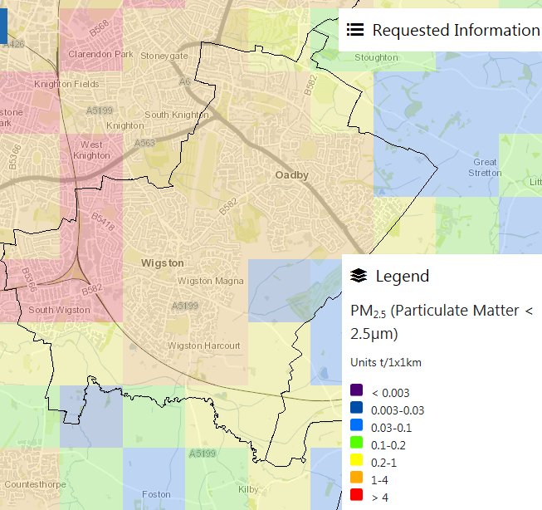

Web extract of PM 2.5 Concentrations across the Borough by 1km grid

Source: <http://naei.beis.gov.uk/emissionsapp/>

## Summary of Monitoring Undertaken

### Automatic Monitoring Sites

Oadby and Wigston Borough Council does not undertake automatic (continuous) monitoring within the Borough.

### Non-Automatic Monitoring Sites

Oadby and Wigston Borough Council undertook non- automatic (passive) monitoring of NO2 at 21 sites during 2018. Table A.1 in Appendix A shows the details of the sites.

Maps showing the location of the monitoring sites are provided in Appendix D. Further details on Quality Assurance/Quality Control (QA/QC) for the diffusion tubes, including bias adjustments and any other adjustments applied (e.g. “annualisation” and/or distance correction), are included in Appendix C.

## Individual Pollutants

The air quality monitoring results presented in this section are, where relevant, adjusted for bias, “annualisation” and distance correction. Further details on adjustments are provided in Appendix C.

### Nitrogen Dioxide (NO2)

Table A.2 in Appendix A compares the ratified and adjusted monitored NO2 annual mean concentrations for the past 5 years with the air quality objective of 40µg/m3.

For diffusion tubes, the full 2018 dataset of monthly mean values is provided in Appendix B.

### Particulate Matter (PM10)

Oadby and Wigston Borough Council does not monitor PM10 concentrations.

### Particulate Matter (PM2.5)

Oadby and Wigston Borough Council does not monitor PM2.5 concentrations.

.

# Appendix A: Monitoring Results

Table A.1 – Details of Non-Automatic Monitoring Sites

|  |  |  |  |  |  |  |  |  |  |  |
| --- | --- | --- | --- | --- | --- | --- | --- | --- | --- | --- |
| **Site ID** | **Site Name** | **Site Type** | **X OS Grid Ref** | **Y OS Grid Ref** | **Pollutants Monitored** | **In AQMA?** | **Distance to Relevant Exposure (m) (1)** | **Distance to kerb of nearest road (m) (2)** | **Tube collocated with a Continuous Analyser?** | **Height (m)** |
| DT1 | Glen Rd, A6 | Kerbside | 463208 | 299913 | NO2 | NO | 12.5 | 5 | NO | 2.2 |
| DT2 | Uplands Rd / Junction A6 | Kerbside | 462590 | 300513 | NO2 | NO | 12.7 | 3.8 | NO | 2.3 |
| DT3 | Victoria Court | Kerbside | 461856 | 301027 | NO2 | NO | 14 | 0.8 | NO | 2.2 |
| DT4 | Church Nook / Bullhead St | Kerbside | 460881 | 299075 | NO2 | NO | 25 | 1.55 | NO | 2.34 |
| DT5 | Leicester Rd, Wigston | Kerbside | 460541 | 299722 | NO2 | NO | 4 | 3.16 | NO | 2.17 |
| DT6 | Shackerdale Rd / Aylestone Ln | Kerbside | 459448 | 299747 | NO2 | NO | 13.4 | 1.42 | NO | 2.36 |
| DT7 | 259 Aylestone Lane | Kerbside | 459329 | 299796 | NO2 | NO | 20 | 0.48 | NO | 2.39 |
| DT8 | 225 Aylestone Lane/West Ave | Kerbside | 459566 | 299690 | NO2 | NO | 17.6 | 2.58 | NO | 2.34 |
| DT9 | Dorset Avenue/Saffron Road | Kerbside | 459329 | 299426 | NO2 | NO | 40 | 1 | NO | 2.2 |
| DT10 | Tigers Lane/Saffron Road | Kerbside | 458454 | 298789 | NO2 | NO | 30 | 0.5 | NO | 2.19 |
| DT11 | Vicarage Blaby Road | Kerbside | 458625 | 298308 | NO2 | NO | 8.3 | 1.55 | NO | 2.17 |
| DT12 | 45 Blaby Road | Kerbside | 458778 | 298335 | NO2 | NO | 3.7 | 0.66 | NO | 2.32 |
| DT13 | 50a Blaby Road | Kerbside | 458912 | 298371 | NO2 | NO | 5.6 | 0.81 | NO | 2.45 |
| DT14 | 4 Canal Street | Kerbside | 458998 | 298371 | NO2 | NO | 1 | 0.5 | NO | 2.21 |
| DT15 | 11 Canal Street | Kerbside | 458979 | 298314 | NO2 | NO | 1.6 | 0.74 | NO | 2.34 |
| DT16 | Canal St / Station Rd | Kerbside | 459012 | 298376 | NO2 | NO | 3.75 | 0.82 | NO | 2.35 |
| DT17 | 4 Station Street | Kerbside | 459015 | 298407 | NO2 | NO | 9.6 | 0.46 | NO | 2.21 |
| DT18 | Health Centre Blaby Road | Kerbside | 459065 | 298400 | NO2 | NO | 6.6 | 3.1 | NO | 2.32 |
| DT19 | 141 Blaby Road | Kerbside | 459163 | 298414 | NO2 | NO | 16.8 | 12.97 | NO | 2.24 |
| DT20 | 2 Lansdown Grove | Kerbside | 459248 | 298438 | NO2 | NO | 9.8 | 2.18 | NO | 2.29 |
| DT21 | Magna Rd / Station Rd | Kerbside | 459337 | 298464 | NO2 | NO | 7.4 | 1.63 | NO | 2.4 |

**Notes:**

(1) 0m if the monitoring site is at a location of exposure (e.g. installed on/adjacent to the façade of a residential property).

(2) N/A if not applicable.

Table A.2 – Annual Mean NO2 Monitoring Results

|  |  |  |  |  |  |  |  |  |  |
| --- | --- | --- | --- | --- | --- | --- | --- | --- | --- |
| **Site ID** | **Site Type** | **Monitoring Type** | **Valid Data Capture for Monitoring Period (%) (1)** | **Valid Data Capture 2018 (%) (2)** | **NO2 Annual Mean Concentration (µg/m3) (3)** | | | | |
| **2014** | **2015** | **2016** | **2017** | **2018** |
| Glen Rd, A6 | Kerbside | Diffusion Tube | N/A |  | 32.36 | 30.06 | 29.92 | 31.17 | 27.4 |
| Uplands Rd / Junction A6 | Kerbside | Diffusion Tube | N/A |  | 31.81 | 32.68 | 32.44 | 24.1 | 27.7 |
| Victoria Court | Kerbside | Diffusion Tube | N/A |  | 37.61 | 36.40 | 34.86 | **44.58** | 37.1 |
| Church Nook / Bullhead St | Kerbside | Diffusion Tube | N/A |  | 27.39 | 25.96 | 25.19 | 25.53 | 22.1 |
| Leicester Rd, Wigston | Kerbside | Diffusion Tube | N/A |  | 30.43 | 27.00 | 28.04 | 27.11 | 25.0 |
| Shackerdale Rd / Aylestone Ln | Kerbside | Diffusion Tube | N/A |  | 31.83 | 32.72 | 32.54 | 33.15 | 28.8 |
| 259 Aylestone Lane | Kerbside | Diffusion Tube | N/A |  |  |  |  | 27.67 | 25.6 |
| 225 Aylestone Lane/West Ave | Kerbside | Diffusion Tube | N/A |  |  |  |  | 32.02 | 27.9 |
| Dorset Avenue/Saffron Road | Kerbside | Diffusion Tube | N/A |  |  |  |  | 26.8 | 24.2 |
| Tigers Lane/Saffron Road | Kerbside | Diffusion Tube | N/A |  |  |  |  | 19.82 | 21.3 |
| Vicarage Blaby Road | Kerbside | Diffusion Tube | N/A |  |  |  |  | 33.32 | 33.7 |
| 45 Blaby Road | Kerbside | Diffusion Tube | N/A |  |  |  |  | 34.56 | 29.4 |
| 50a Blaby Road | Kerbside | Diffusion Tube | N/A |  |  |  |  | 26.74 | 25.7 |
| 4 Canal Street | Kerbside | Diffusion Tube | N/A |  |  |  |  | 26.26 | 28.1 |
| 11 Canal Street | Kerbside | Diffusion Tube | N/A |  |  |  |  | 23.65 | 22.0 |
| Canal St / Station Street | Kerbside | Diffusion Tube | N/A |  | 38.55 | 39.65 | 39.17 | 36.77 | 34.4 |
| 4 Station Street | Kerbside | Diffusion Tube | N/A |  |  |  |  | 27.03 | 24.4 |
| Health Centre Blaby Road | Kerbside | Diffusion Tube | N/A |  |  |  |  | 30.03 | 26.5 |
| 141 Blaby Road | Kerbside | Diffusion Tube | N/A |  |  |  |  | 20.92 | 21.0 |
| 2 Lansdown Grove | Kerbside | Diffusion Tube | N/A |  |  |  |  | 26.22 | 25.0 |
| Magna Rd / Station Rd | Kerbside | Diffusion Tube | N/A |  | 27.55 | 27.81 | 25.17 | 25.13 | 25.2 |

**Diffusion tube data has been bias corrected**

**Annualisation has been conducted where data capture is <75%**

**Notes:**

Exceedances of the NO2 annual mean objective of 40µg/m3 are shown in **bold**.

NO2 annual means exceeding 60µg/m3, indicating a potential exceedance of the NO2 1-hour mean objective are shown in **bold and underlined.**

(1) Data capture for the monitoring period, in cases where monitoring was only carried out for part of the year.

(2) Data capture for the full calendar year (e.g. if monitoring was carried out for 6 months, the maximum data capture for the full calendar year is 50%).

(3) Means for diffusion tubes have been corrected for bias. All means have been “annualised” as per Boxes 7.9 and 7.10 in LAQM.TG16 if valid data capture for the full calendar year is less than 75%. See Appendix C for details.

Figure A.1 – Trends in Annual Mean NO2 Concentrations

.

# Appendix B: Full Monthly Diffusion Tube Results for 2018

Table B.1 – NO2 Monthly Diffusion Tube Results - 2018

|  |  |  |  |  |  |  |  |  |  |  |  |  |  |  |  |
| --- | --- | --- | --- | --- | --- | --- | --- | --- | --- | --- | --- | --- | --- | --- | --- |
| **Site ID** | **NO2 Mean Concentrations (µg/m3)** | | | | | | | | | | | | | | |
| **Jan** | **Feb** | **Mar** | **Apr** | **May** | **Jun** | **Jul** | **Aug** | **Sep** | **Oct** | **Nov** | **Dec** | **Annual Mean** | | |
| **Raw Data** | **Bias Adjusted (0.76) and Annualised (1)** | **Distance Corrected to Nearest Exposure (2)** |
| Glen Rd, A6 | 42.8 | 42.1 | 36.1 | 35.2 | 26.6 | 31.1 | 35.1 | 35.4 | 35.3 | 38.0 | 33.7 | 41.4 | 36.1 | 27.4 | 24.0 |
| Uplands Rd / Junction A6 | 40.4 | 39.0 | 36.1 | 30.1 | 28.8 | 25.9 | 33.9 | 41.6 | 42.3 | 46.4 | 36.7 | Missing | 36.5 | 27.7 | 25.4 |
| Victoria Court | 64.2 | 53.7 | 46.9 | 46.3 | 35.7 | 28.5 | 43.8 | 52.3 | 52.7 | 54.3 | 51.6 | 55.6 | **48.8** | 37.1 | 25.9 |
| Church Nook / Bullhead St | 32 | 32.4 | 28.1 | 25.8 | 22.2 | 17.8 | 27.9 | 28.9 | 31.4 | 35 | 31.4 | 36.1 | 29.1 | 22.1 | 19.0 |
| Leicester Rd, Wigston | 41.2 | 36.1 | 36.6 | 31.4 | 27.9 | 24 | 28 | 29.9 | 30.6 | 33.9 | 35.8 | 38.6 | 32.8 | 25.0 | 24.0 |
| Shackerdale Rd / Aylestone Ln | 43.9 | 39.9 | 37.2 | 36.3 | 31 | 30.1 | 35.5 | 40.7 | 39.1 | 44.6 | 38.7 | Missing | 37.9 | 28.8 | 25.3 |
| 259 Aylestone Lane | 46.1 | 25.7 | 39.7 | 33.6 | 23.9 | 19.5 | 31.3 | 33.6 | 33.7 | 39.9 | 41.6 | 47.5 | 33.6 | 25.6 | 21.9 |
| 225 Aylestone Lane/West Ave | 47.3 | 39.2 | 40.4 | 33.6 | 24.8 | 20.9 | 29.9 | 34.7 | 33.5 | 40.9 | 47.9 | 47.6 | 36.7 | 27.9 | 25.0 |
| Dorset Avenue/Saffron Road | 33.7 | 32.1 | 32.5 | 25.5 | 26.4 | 21.6 | 28.3 | 33.7 | 33.4 | 38.6 | 41.3 | 34.6 | 31.8 | 24.2 | 21.3 |
| Tigers Lane/Saffron Road | 31.5 | 31.2 | 30.1 | 22.8 | 25.8 | 23 | 22.4 | 22.4 | 23 | 33.4 | 35.7 | 34.7 | 28.0 | 21.3 | 20.3 |
| Vicarage Blaby Road | 38.4 | 52.1 | 51.4 | 42.4 | 45.9 | 41.5 | 42.7 | 39.1 | 40.8 | 47.9 | 45.2 | Missing | **44.3** | 33.7 | 28.0 |
| 45 Blaby Road | 34.4 | 43.1 | 44.2 | 35.8 | 30.9 | 26.7 | 38.6 | 38.5 | 40.6 | 44.4 | 43.3 | 44 | 38.7 | 29.4 | 25.7 |
| 50a Blaby Road | Missing | 36 | 38.3 | 31 | 28.7 | 25.7 | 32.5 | 34.3 | 30.4 | 39.3 | 38.4 | 36.9 | 33.8 | 25.7 | 22.8 |
| 4 Canal Street | 38.5 | 39.6 | 43.1 | 31.6 | 35.4 | 33.4 | 35.1 | 36.2 | 33 | 44.2 | 36.4 | Missing | 37.0 | 28.1 | 26.4 |
| 11 Canal Street | 33.7 | 29.6 | 35.9 | 28.2 | 26.6 | 24 | 26.6 | 29.1 | 27.6 | 35.7 | 26.5 | Missing | 29.0 | 22.0 | 21.4 |
| Canal St / Station Street | 43 | 48.8 | 43.9 | 41.4 | 45.8 | 46.3 | 46.4 | 46 | 42.8 | 52.6 | 40.6 | Missing | **45.2** | 34.4 | 29.4 |
| 4 Station Street | 38.9 | 36.4 | 34.3 | 29 | 25.9 | 23 | 25 | 31.3 | 31.7 | 37.9 | 34.4 | 37.3 | 32.1 | 24.4 | 21.2 |
| Health Centre Blaby Road | 43.1 | Missing | 38.7 | 33.3 | 26.1 | 27 | 32.5 | 33.7 | 35.7 | 40.3 | 37.8 | Missing | 34.8 | 26.5 | 24.9 |
| 141 Blaby Road | 31.4 | 36 | 33.4 | 23.1 | 25.7 | 22.9 | 19.2 | 23.4 | 24.1 | 34.4 | 30.9 | Missing | 27.7 | 21.0 | 20.8 |
| 2 Lansdown Grove | 35.6 | 38.2 | 33.1 | 24.9 | 36.1 | 32.7 | 32 | 30.3 | 30.5 | 37.5 | 28.6 | 34.5 | 32.8 | 25.0 | 22.6 |
| Magna Rd / Station Rd | 38.6 | 34.9 | 30.7 | 34.2 | 34.4 | 33.4 | 26 | 28.5 | 27.5 | 38.2 | 34.1 | 37.8 | 33.2 | 25.2 | 23.0 |

**Local bias adjustment factor used**

**National bias adjustment factor used**

**Annualisation has been conducted where data capture is <75%**

**Where applicable, data has been distance corrected for relevant exposure**

**Notes:**

Exceedances of the NO2 annual mean objective of 40µg/m3 are shown in **bold**.

NO2 annual means exceeding 60µg/m3, indicating a potential exceedance of the NO2 1-hour mean objective are shown in **bold and underlined.**

(1) See Appendix C for details on bias adjustment and annualisation.

(2) Distance corrected to nearest relevant public exposure.

# Appendix C: Supporting Technical Information / Air Quality Monitoring Data QA/QC

**Diffusion Tube Bias Adjustment Factors**

The tube supplier/analyst is Harwell Scientifics which is now part of Environmental Services Group. The laboratory uses 50% TEA in Acetone to calculate the nitrogen dioxide level. Following analysis by the laboratory, the results are then adjusted for bias. The bias adjustment figures (as taken from the DEFRA web-site) are shown in the table below. A factor from a co-location study was not considered as Oadby and Wigston Borough Council did not conduct any such study. Spreadsheet version 09/17 was used to obtain the bias adjustment figure for 2017.

**Bias adjustment figures used between 2003 and 2017**

|  |  |
| --- | --- |
| Year | Bias Adjustment value |
| 2003 | 0.90 |
| 2004 | 0.90 |
| 2005 | 0.91 |
| 2006 | 0.99 |
| 2007 | 0.84 & 0.81 |
| 2008 | 0.80 |
| 2009 | 0.81 |
| 2010 | 0.85 |
| 2011 | 0.84 |
| 2012 | 0.79 |
| 2013 | 0.80 |
| 2014 | 0.81 |
| 2015 | 0.81 |
| 2016 | 0.77 |
| 2017 | 0.77 |
| 2018 | 0.76 |

**Discussion of Choice of Factor to Use**

Oadby and Wigston Borough Council have not conducted any co-location studies, the national bias adjustment factor was the only available option.

**QA/QC of diffusion tube monitoring**

The tube precision information was taken from the DEFRA website. On the table summarising the precision results for nitrogen dioxide diffusion tube collocation studies, Environmental Services Group had a good level of precision in tests conducted in 2016.

The WASP/AIR NO2 Proficiency Testing scheme reports on laboratories that have demonstrated satisfactory performance with the scheme for analysis of NO2 diffusion tubes. For WASP round AIR PT AR018 (April 2017 to February 2018) overall 100% of results submitted by Environmental Services Group were determined to be satisfactory based upon a z score of < ± 2. The tube precision information was taken from the DEFRA website.[4]

|  |  |  |  |
| --- | --- | --- | --- |
| April – May 2017 | July – August 2017 | September – October 2017 | January – February 2018 |
| 100 % | 100% | 100 % | 100% |

The summary of all results for 2018 from ESG Didcot were all good

**Background NO2 levels for Oadby and Wigston Borough Council**

Background NO2 levels for Oadby and Wigston Borough Council taken from the National Air Quality Archive at <https://uk-air.defra.gov.uk/data/laqm-background-maps?year=2017>

|  |  |  |  |
| --- | --- | --- | --- |
| **Tube Nos** | **Diffusion Tube Site** | **X** | **Y** |
| 1 | Glen Rd, A6 | 463208 | 299913 |
| 2 | Uplands Rd / Junction A6 | 462590 | 300513 |
| 3 | Victoria Court | 461856 | 301027 |
| 4 | Church Nook / Bullhead St | 460881 | 299075 |
| 5 | Leicester Rd, Wigston | 460541 | 299722 |
| 6 | Shackerdale Rd / Aylestone Ln | 459448 | 299747 |
| 7 | 259 Aylestone Lane | 459329 | 299796 |
| 8 | 225 Aylestone Lane/West Ave | 459566 | 299690 |
| 9 | Dorset Avenue/Saffron Road | 459329 | 299426 |
| **Tube Nos** | **Diffusion Tube Site** | **X** | **Y** |
| 10 | Tigers Lane/Saffron Road | 458454 | 298789 |
| 11 | Vicarage Blaby Road | 458625 | 298308 |
| 12 | 45 Blaby Road | 458778 | 298335 |
| 13 | 50a Blaby Road | 458912 | 298371 |
| 14 | 4 Canal Street | 458998 | 298371 |
| 15 | 11 Canal Street | 458979 | 298314 |
| 16 | Canal St / Station Rd | 459012 | 298376 |
| 17 | 4 Station Street | 459015 | 298407 |
| 18 | Health Centre Blaby Road | 459065 | 298400 |
| 19 | 141 Blaby Road | 459163 | 298414 |
| 20 | 2 Lansdown Grove | 459248 | 298438 |
| 21 | Magna Rd / Station Rd | 459337 | 298464 |

|  |  |  |  |
| --- | --- | --- | --- |
| **Site Nos** | **X** | **Y** | **2017 Background Concentrations (μg/m3)** |
| 7,8,11,12,13,14,15 | 458500 | 298500 | 18.27081 |
| 6,9,10,16,17,18,19,  20,21 | 459500 | 298500 | 18.49219 |
| 4,5,6 | 460500 | 299500 | 17.73338 |
| 3 | 461500 | 301500 | 16.73851 |
| 1 | 463500 | 299500 | 14.79068 |
| 2 | 463500 | 300500 | 15.62814 |

Site allocation of Background 2017 NO2 Concentrations (μg/m3) used for Façade correction calculations

# Appendix D: Map(s) of Monitoring Locations and AQMAs

|  |
| --- |
| Map 1.4  Map 1.3  Map 1.2  Map 1.1  Harborough District Council  Blaby District Council  Leicester City |

Map 1.1 South Wigston - Passive NO2 Tube Locations

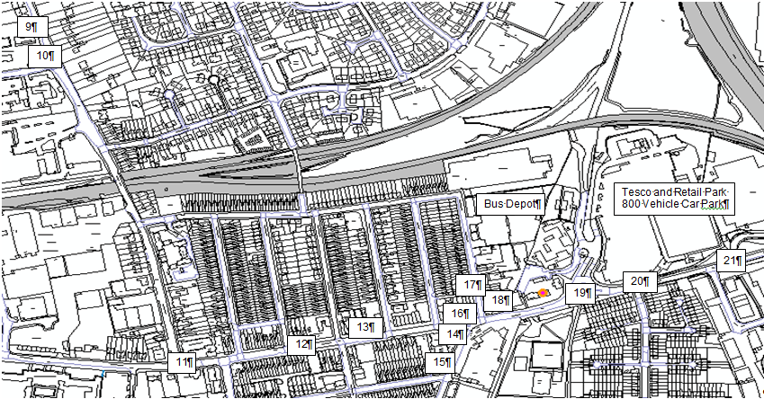

Map 1.2 Aylestone Lane - Shackerdale Road Passive NO2 Diffusion Tube Locations

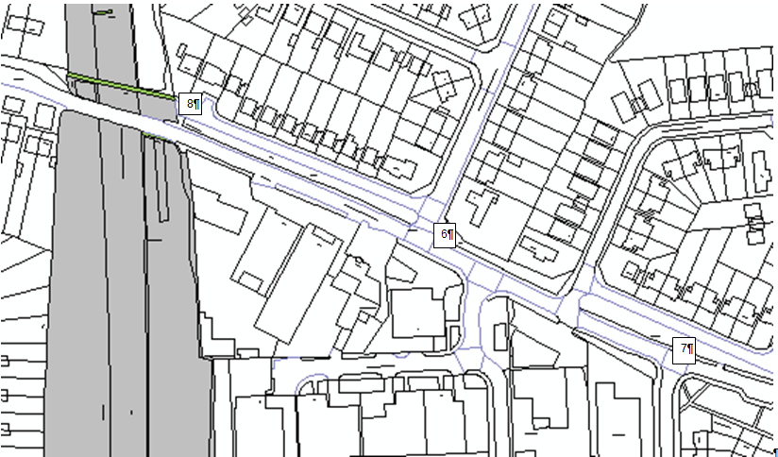

Map 1.3 Leicester Road – Bull Head Street Passive NO2 Diffusion Tube Locations

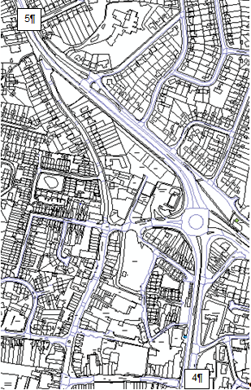

Map 1.4 A6 - Harborough Road Oadby Passive NO2 Diffusion Tube Locations

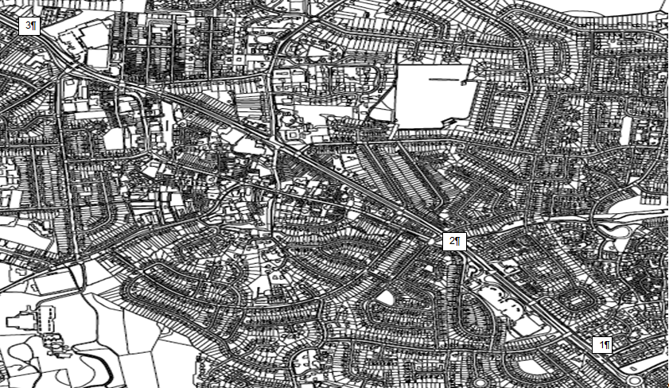

# Appendix E: Summary of Air Quality Objectives in England

Table E.1 – Air Quality Objectives in England

| **Pollutant** | **Air Quality Objective[5]** | |
| --- | --- | --- |
| **Concentration** | **Measured as** |
| Nitrogen Dioxide (NO2) | 200 µg/m3 not to be exceeded more than 18 times a year | 1-hour mean |
| 40 µg/m3 | Annual mean |
| Particulate Matter (PM10) | 50 µg/m3, not to be exceeded more than 35 times a year | 24-hour mean |
| 40 µg/m3 | Annual mean |
| Sulphur Dioxide (SO2) | 350 µg/m3, not to be exceeded more than 24 times a year | 1-hour mean |
| 125 µg/m3, not to be exceeded more than 3 times a year | 24-hour mean |
| 266 µg/m3, not to be exceeded more than 35 times a year | 15-minute mean |

**Appendix F:**

**Façade Calculation**

Glen Road, Oadby

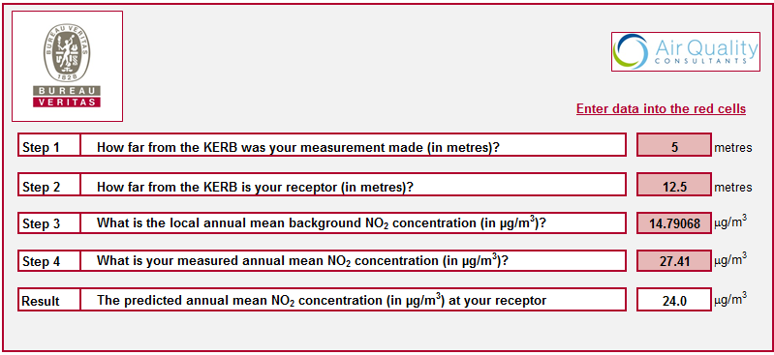

Uplands Road / Junction A6

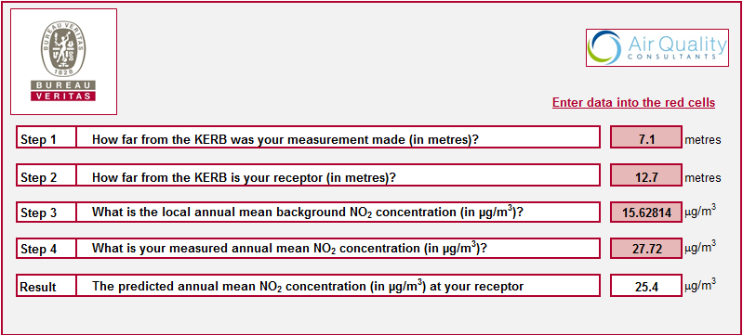

Victoria Court

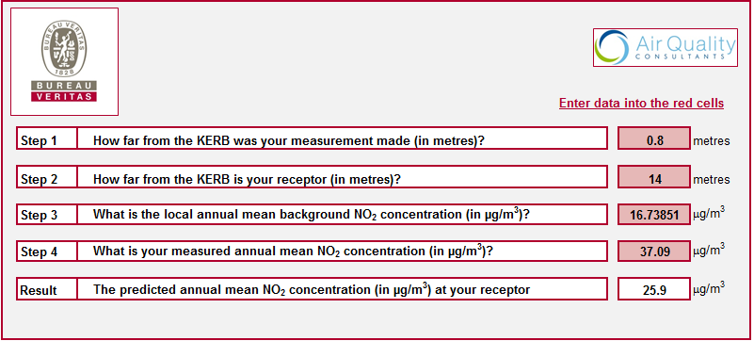

Church Nook / Bullhead Street

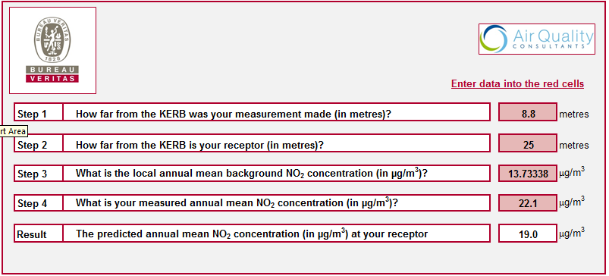

Leicester Road, Wigston

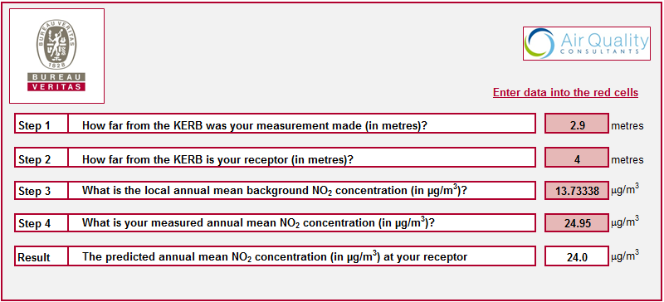

Shackerdale Road/ Aylestone Lane

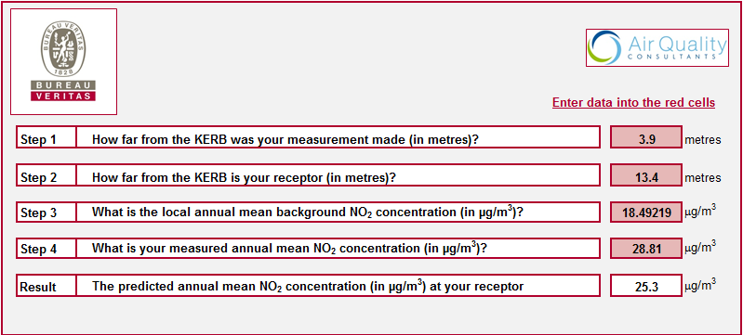

Dorset Avenue / Saffron Road

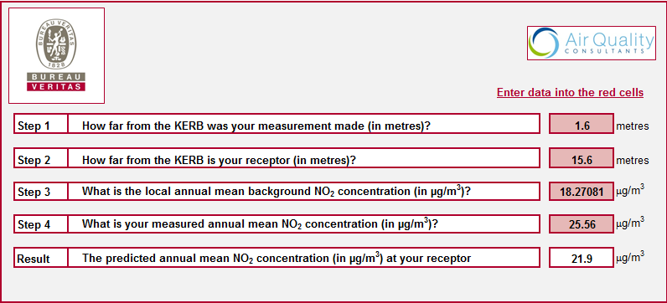

Tigers Lane / Saffron Road

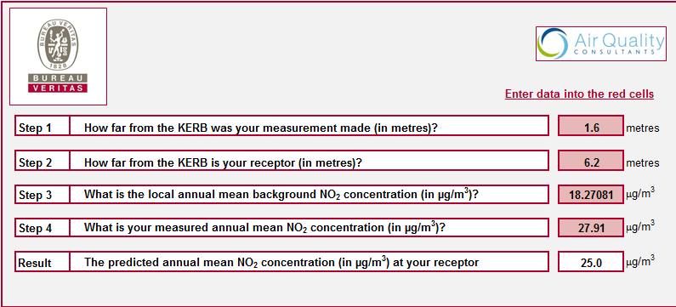

259 Aylestone Lane

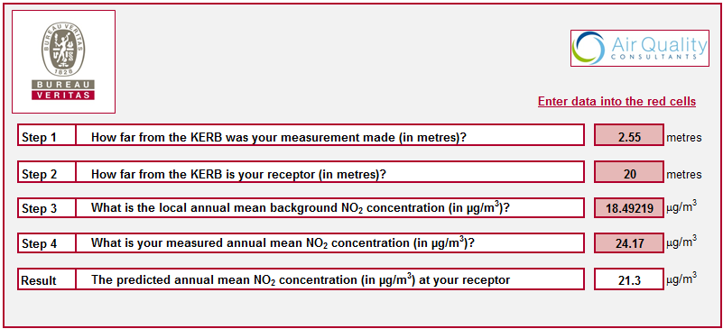

225 Aylestone Lane / West Avenue

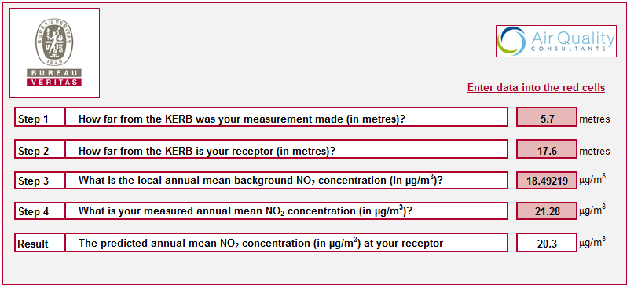

Vicarage, Blaby Road

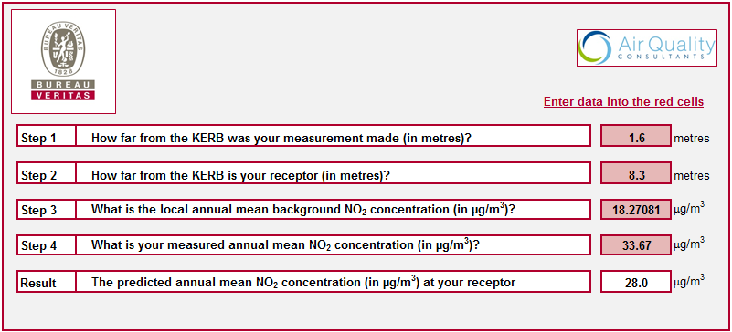

45 Blaby Road

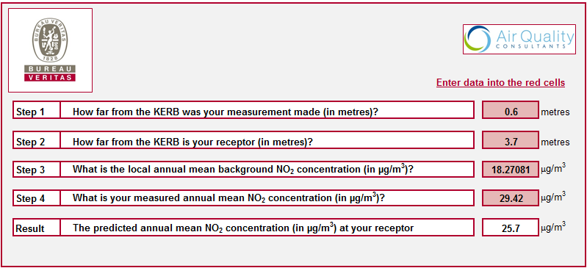

50a Blaby Road

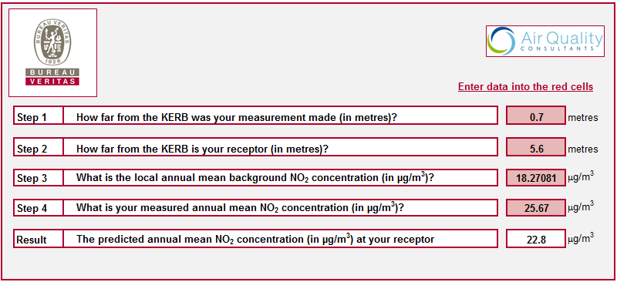

4 Canal Street

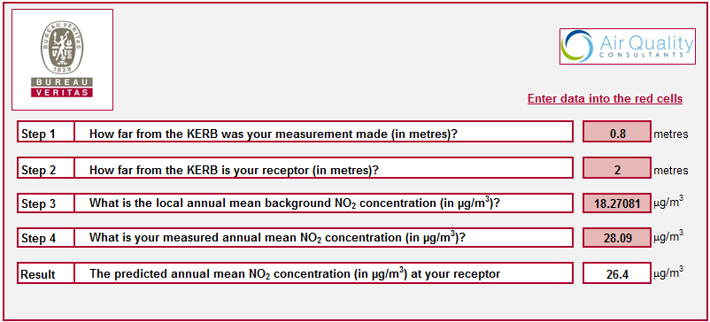

11 Canal Street

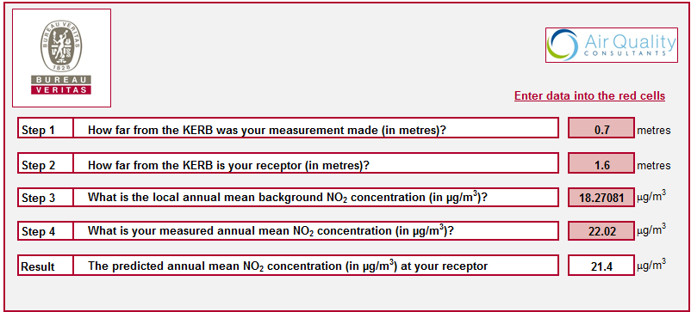

Canal Street / Station Road

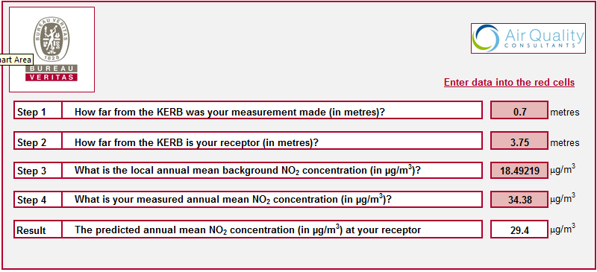

4 Station Road

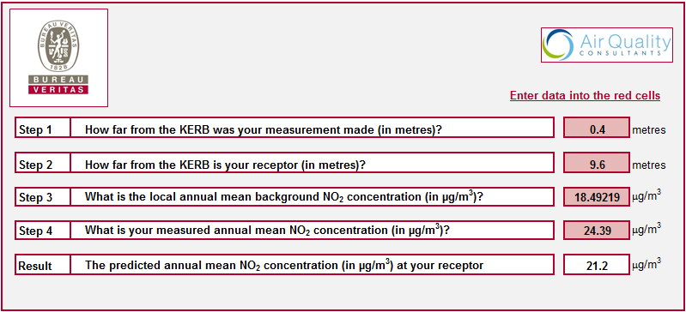

Health Centre, Blaby Road

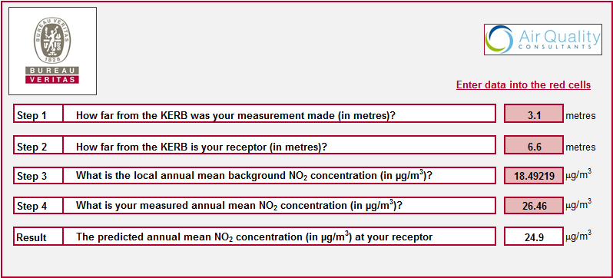

141 Blaby Road

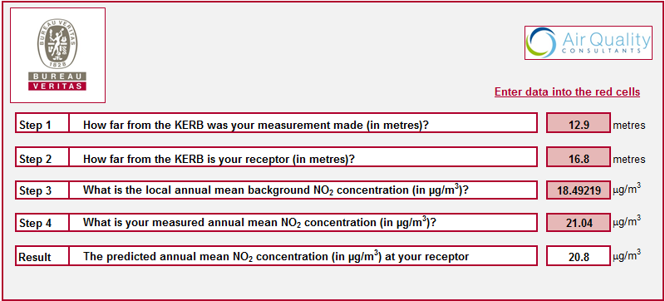

2 Lansdown Road

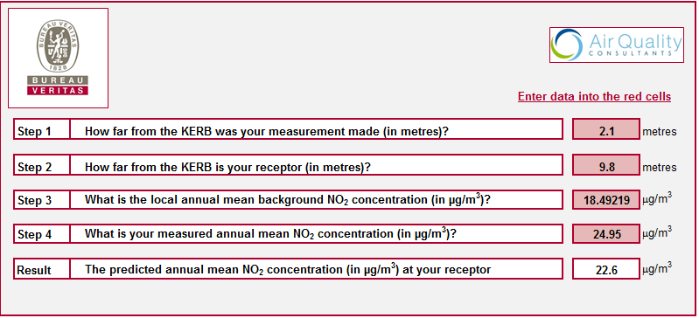

Magna Road / Station Road

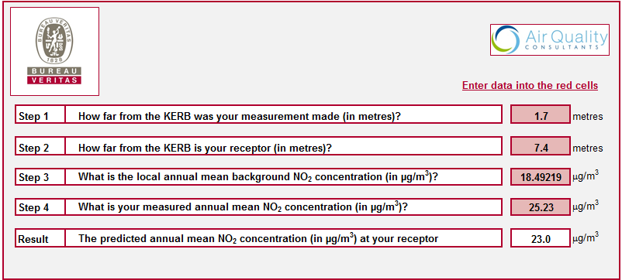

**Appendix G:**

**G1 - Oadby Community Forum Briefing Paper**

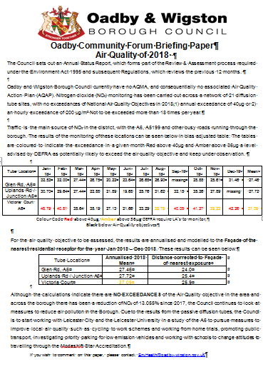

**G2 Wigston Community Forum Briefing Paper**

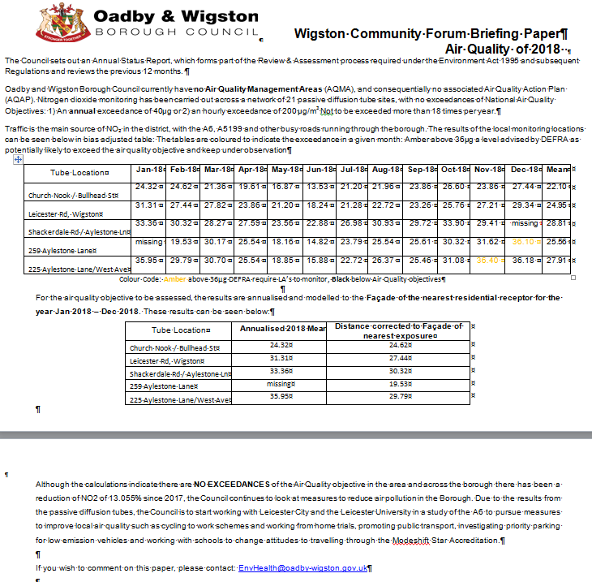

**G3 South Wigston Community Forum Briefing Paper**

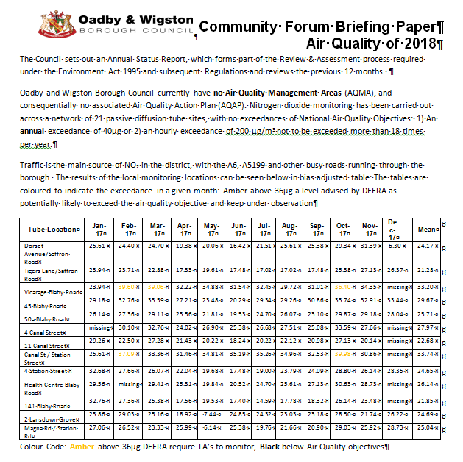

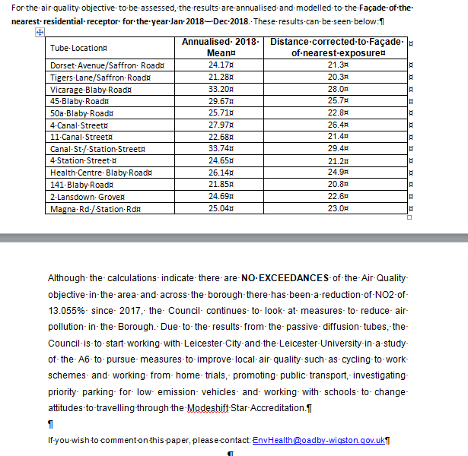

# Glossary of Terms

|  |  |
| --- | --- |
| **Abbreviation** | **Description** |
| AQAP | Air Quality Action Plan - A detailed description of measures, outcomes, achievement dates and implementation methods, showing how the local authority intends to achieve air quality limit values’ |
| AQMA | Air Quality Management Area – An area where air pollutant concentrations exceed / are likely to exceed the relevant air quality objectives. AQMAs are declared for specific pollutants and objectives |
| ASR | Air quality Annual Status Report |
| Defra | Department for Environment, Food and Rural Affairs |
| DMRB | Design Manual for Roads and Bridges – Air quality screening tool produced by Highways England |
| EU | European Union |
| FDMS | Filter Dynamics Measurement System |
| LAQM | Local Air Quality Management |
| NO2 | Nitrogen Dioxide |
| NOx | Nitrogen Oxides |
| PM10 | Airborne particulate matter with an aerodynamic diameter of 10µm (micrometres or microns) or less |
| PM2.5 | Airborne particulate matter with an aerodynamic diameter of 2.5µm or less |
| QA/QC | Quality Assurance and Quality Control |
| SO2 | Sulphur Dioxide |
| … | … |

# References

1. DEFRA (2018), Local Air Quality Management: Technical Guidance, LAQM.TG(16), London, Crown Copyright <https://laqm.defra.gov.uk/technical-guidance/>
2. Oadby and Wigston Borough Council (2015), Updating and Screening Assessment 2015.
3. Oadby and Wigston Borough Council (2016), Updating and Screening Assessment 2016.
4. Oadby and Wigston Borough Council (2017), Updating and Screening Assessment 2017.
5. Oadby and Wigston Borough Council (2018), Updating and Screening Assessment 2018.
6. National Diffusion Tube Bias Adjustment Factor Spreadsheet URL <http://laqm.defra.gov.uk/bias-adjustment-factors/national-bias.html>
7. Calculator to predict nitrogen dioxide concentrations at different distances from roads, URL Address: <http://laqm.defra.gov.uk/tools-monitoring-data/no2-falloff.html>
8. Report used to confirm WASP/AIR PT scheme information on Environmental Services Group, Didcot, URL Address: <https://laqm.defra.gov.uk/assets/AIR-PT-Rounds-13-to-24-Apr-2016-Feb-2018.pdf>
9. Summary of Precision Results for Nitrogen Dioxide Diffusion Tube Collocation Studies, by Laboratory, URL Address: <https://laqm.defra.gov.uk/assets/tubeprecision2018version0619finalreduced.pdf>
10. Estimated background air pollution maps, URL Address:
11. <https://uk-air.defra.gov.uk/data/laqm-background-maps?year=2017>

1. Environmental equity, air quality, socioeconomic status and respiratory health, 2010
2. Air quality and social deprivation in the UK: an environmental inequalities analysis, 2006
3. Defra. Abatement cost guidance for valuing changes in air quality, May 2013
4. <https://laqm.defra.gov.uk/assets/airptrounds7to18apr2015feb2017.pdf>
5. The units are in microgrammes of pollutant per cubic metre of air (µg/m3).