2022 Air Quality Annual Status Report (ASR)

In fulfilment of Part IV of the Environment Act 1995 Local Air Quality Management
Date: July, 2022

Information | Oadby and Wigston Borough Council
Local Authority Officer | Jon Wells
Department | Regulatory Services
Address | Council Offices,  Bushloe House,  Station Road,  Wigston,  Leicestershire,  LE18 2DR
Telephone | 0116 2888961
E-mail | jon.wells@oadby-wigston.gov.uk
Report Reference Number | OWBC ASR 2022
Date | July 2022

Executive Summary: Air Quality in Our Area

Air Quality in Oadby and Wigston
Air pollution is associated with a number of adverse health impacts. It is recognised as a contributing factor in the onset of heart disease and cancer. Additionally, air pollution particularly affects the most vulnerable in society: children, the elderly, and those with existing heart and lung conditions. There is also often a strong correlation with equalities issues because areas with poor air quality are also often less affluent areas,.
The mortality burden of air pollution within the UK is equivalent to 28,000 to 36,000 deaths at typical ages, with a total estimated healthcare cost to the NHS and social care of £157 million in 2017.
The main pollutants of concern are those associated with traffic, the borough being on the outskirts of Leicester City with a number of arterial routes leading through it. The area is situated within the County of Leicestershire and both the City and County place controls on transport and main transport routes through our borough. This is having a positive effect on local air pollution and collaborative work benefits our residents.
The largest contributor to air pollution and climate change both arise from the emission to atmosphere of the products of combustion, with particular issues relating to nitrous oxides. They are intrinsically linked. National policy advises local authorities to ‘bear in mind the synergies between air quality and climate change, and the added benefits to the local, regional and global environment of having an integrated approach to tackling both climate change and air quality goals.’
“Joined up policies are particularly important for the transport sector, which is by far the most common cause for the declaration of air quality management areas and is the only sector where carbon dioxide emissions continue to increase.”
The consolidated, summary of transport options taken forward into the Leicester City 2011 - 2026 LTP and the Leicestershire County Council 2011/2026 LTP3 Strategy represented a package of realistic, medium range measures. These are mainly centred upon improving bus services and managing demand for travel by car, this has had the effect of reducing the potential pollution from vehicle emissions crossing into the Borough.
The trend for 2021 showed all areas monitored were within the Air Quality Objectives (AQOs). Two areas where NO2 are the highest are A6 Oadby – Victoria Court (DT3) and Canal St (DT16). Overall there has been a year on year reduction in Nitrogen Dioxide since 2019. A Zephyr sensor was set up in May 2020 as part of a network of monitoring around the Leicester City ring roads and this has further identified that none of the air quality objectives for Nitrogen Dioxide (NO2), Ozone (O3), Nitrogen Oxide (NO), Particulate Matter (PM1, PM2.5 and PM10) were breached. Real time data from the chemiluminescent and Zephyr sensor will be made available on a publicly accessible website, during 2022.

Actions to Improve Air Quality
Whilst air quality has improved significantly in recent decades, and will continue to improve due to national policy decisions, there are some areas where local action is needed to improve air quality further.
The 2019 Clean Air Strategy sets out the case for action, with goals to reduce exposure to harmful pollutants. The Road to Zero sets out the approach to reduce exhaust emissions from road transport through a number of mechanisms; this is extremely important given that the majority of Air Quality Management Areas (AQMAs) are designated due to elevated concentrations heavily influenced by transport emissions.
In common with many other local authorities there is significant housing growth within the borough. There are currently no Air Quality Management Areas (AQMAs) and as such no additional resources have been allocated to this area of work. The Council continues to measure air quality using a network of 21 diffusion tubes across the borough. In addition there is a Zephyr sensor along the A6 (installed in 2020) and in May 2022 a chemiluminescent air quality monitoring station was installed and commissioned situated at the junction of Canal Street and Blaby Road, near to a diffusion tube (DT16). This will form part of a colocation study during 2022, having been delayed following the pandemic. Consultation continues with our planning team where we provide pre-application advice and give a subjective view on the effect any development may have on the AQOs. In the last few years the Council have successfully obtained unilateral undertaking contributions from two large developments towards air quality monitoring. This will be used to provide financial support for the Zephyr and the chemiluminescent monitoring station.
The Leicestershire ‘Air Quality Joint Strategic Needs Assessment’ (JSNA) was published in May 2019 https://www.lsr-online.org/uploads/jsna-air-quality-2019-v10-final.pdf?v=1561477116. It contained a ‘next steps’ recommendation around the need for the development and co-ordination of interventions that improve local air quality for everyone, not just based around pollution hotspots and Air Quality Management Areas that are identified and monitored by District or Borough Councils. This approach was identified as giving potential for greatest impact on improving health, as air quality can affect the health of our population throughout the life course at any age, and disproportionately affect the most vulnerable contributing to health inequalities.
To underpin this work, the JSNA recommended a partnership approach to create improvements in how we understand air pollution, reduce our contribution to it and mitigate against its risks to health. One such project will commence during 2022, with our Public Health colleagues at the Leicestershire County Council where we will be working with schools, academies and colleges along Blaby Road, South Wigston leading into Wigston. The Oadby and Wigston Borough Council area is one identified by Public Health colleagues as having a large number of children presenting to the emergency department for asthma and viral wheeze. Data shows there were 1,303 admissions per 100,000 of population, the highest across the County for the period 2017-20. The main route from South Wigston, leading into Wigston (Blaby Road) will therefore be targeted for intervention. The project will include all partners, this Council, Leicestershire County Council (Public Health, Highway and Active Travel teams) along with the Schools, College representatives, students, health partners and bus companies. Others will be included as and when required with the following seen as key work areas:
- Increased measurement and reporting of different forms of air pollution
- Development of active travel programmes
- Educational ‘healthy schools’ programmes all with the aim of improving understanding, raising awareness and contributing towards and influencing outcomes.
The Council, prompted by the pandemic, has now adopted an agile working policy. With an impending move to another office base, this will gather momentum during 2022 and 2023.

Conclusions and Priorities
The Council in its Local Plan 2019 -2031 adopted April 2019 makes provision for an additional 2960 Homes to be developed between 2011 – 2031. The main areas for growth are towards the south east of Wigston, between Newton Lane and Welford Road, the north of Oadby along Gartree Road, and the south west of Oadby, along the A6. Of the 2960 new homes set out within the Local Plan, at least 2000 are to be provided within the main areas of growth mentioned. Larger scale directions for growth developments are vitally important as they allow the Council to require infrastructure needed by local communities and the sustainability agenda, for example locating new homes close to facilities and places of work. Brownfield land development and re-development continues to remain a Council priority in terms of new homes provision, right across the Borough area.
The Council’s Local Plan, Policy 5 ‘Health and Wellbeing’ further sets out that development proposals will be required to assess their impact upon existing services and facilities, specifically services and facilities relating to health, social wellbeing, culture and recreation.
Monitoring has been undertaken through the use of passive diffusion tubes and the a Zephyr sensor. Both indicate there is currently no requirement to award an AQMA as all recorded levels are below the air quality objectives.
The bias adjustment figures for the diffusion tubes show that since 2019 NO2 levels have fallen on average by 30.8%.
This situation will be kept under review, additional monitoring as outlined earlier is being undertaken and ongoing dialogue with our highway authority will continue to make them aware and help influence future decisions. Additional real time data during 2022 will be pivotal to providing additional context and access to our data.

Local Engagement and How to get Involved
The Council has a Community Forum Panel (established during the pandemic) where information is shared and consulted upon. Information is also made available through social media and shared with our outreach teams as part of our community engagement. For the first time during 2022 real time air quality monitoring data will be accessible for all to view. The Licensing and Regulatory Committee members receive updates and influence key decisions.
The Blaby Road Project will be a critical project going forward where multiple partners will be able to contribute and take part.
The draft ASR 2022 is shared with the panel, through our social media channels, with elected members, the Public Health Team at County and with other Council teams.
To encourage our communities to be more aware and start to think about their personal impact on local air quality we link promote the following links on active travel – https://www.activeoadbywigston.org.uk/get-active and
https://www.choosehowyoumove.co.uk/
The final ASR 2022 once submitted to DEFRA will be on the Council’s website with all previous reports and DEFRA comments, for transparency and to inform residents, businesses and developers at https://www.Oadby-Wigston.gov.uk/pages/air_quality.

Local Responsibilities and Commitment
This ASR was prepared by the Regulatory Services Department of Oadby and Wigston Borough Council with the support and agreement of the following officers and departments:
Planning
Health and Wellbeing
Economic Generation
Corporate Assets
This ASR has been approved by:
Head of Law and Governance and the Director of Public Health.
If you have any comments on this ASR please send them to Jon Wells at:
Council Offices, Bushloe House, Station Road, Wigston, Leicestershire,LE18 2DR
jon.wells@oadby-wigston.gov.uk

Table of Contents
Executive Summary: Air Quality in Our Area i
Air Quality in <Local Authority Name> i
Actions to Improve Air Quality ii
Conclusions and Priorities iv
Local Engagement and How to get Involved v
Local Responsibilities and Commitment v
1 Local Air Quality Management 1
2 Actions to Improve Air Quality 2
2.1 Air Quality Management Areas 2
2.2 Progress and Impact of Measures to address Air Quality in <Local Authority Name> 3
2.3 PM_{2.5} – Local Authority Approach to Reducing Emissions and/or Concentrations 8
3 Air Quality Monitoring Data and Comparison with Air Quality Objectives and National Compliance 9
3.1 Summary of Monitoring Undertaken 9
3.1.1 Automatic Monitoring Sites 9
3.1.2 Non-Automatic Monitoring Sites 9
3.2 Individual Pollutants 9
3.2.1 Nitrogen Dioxide (NO₂) 10
3.2.2 Particulate Matter (PM₁₀) Error! Bookmark not defined.
3.2.3 Particulate Matter (PM_{2.5}) 10
3.2.4 Sulphur Dioxide (SO₂) 11
Appendix A: Monitoring Results 12
Appendix B: Full Monthly Diffusion Tube Results for 2021 28
Appendix C: Supporting Technical Information / Air Quality Monitoring Data QA/QC 29
New or Changed Sources Identified Within <Local Authority Name> During <Year> 29
Additional Air Quality Works Undertaken by <Local Authority Name> During <Year> 29
QA/QC of Diffusion Tube Monitoring 29
Diffusion Tube Annualisation 30
Diffusion Tube Bias Adjustment Factors 30
NO₂ Fall-off with Distance from the Road 31
QA/QC of Automatic Monitoring 31
PM₁₀ and PM_{2.5} Monitoring Adjustment 32
Automatic Monitoring Annualisation 32
NO₂ Fall-off with Distance from the Road 32
Appendix D: Map(s) of Monitoring Locations and AQMAs 36
Appendix E: Summary of Air Quality Objectives in England 42
Glossary of Terms 43
References 44

Figures
Figure A.1 – Trends in Annual Mean NO₂ Concentrations 18
Figure A.2 – Trends in Number of NO₂ 1-Hour Means > 200µg/m³ 20
Figure A.3 – Trends in Annual Mean PM₁₀ Concentrations 22
Figure A.4 – Trends in Number of 24-Hour Mean PM₁₀ Results > 50µg/m³ 24
Figure A.5 – Trends in Annual Mean PM_{2.5} Concentrations 26
Figure D.1 – Map of Non-Automatic Monitoring Site 36
Table 2.2 – Progress on Measures to Improve Air Quality 6
Table A.1 – Details of Automatic Monitoring Sites 12
Table A.2 – Details of Non-Automatic Monitoring Sites 13
Table A.3 – Annual Mean NO₂ Monitoring Results: Automatic Monitoring (µg/m³) 15
Table A.4 – Annual Mean NO₂ Monitoring Results: Non-Automatic Monitoring (µg/m³) 16
Table A.5 – 1-Hour Mean NO₂ Monitoring Results, Number of 1-Hour Means > 200µg/m³ 19
Table A.6 – Annual Mean PM₁₀ Monitoring Results (µg/m³) 21
Table A.7 – 24-Hour Mean PM₁₀ Monitoring Results, Number of PM₁₀ 24-Hour Means > 50µg/m³ 23
Table A.8 – Annual Mean PM_{2.5} Monitoring Results (µg/m³) 25
Table A.9 – SO₂ 2021 Monitoring Results, Number of Relevant Instances 27
Table B.1 – NO₂ 2021 Diffusion Tube Results (µg/m³) 28
Table C.1 – Bias Adjustment Factor 31
Table C.2 – Annualisation Summary (concentrations presented in µg/m³) 33
Table C.3 – Local Bias Adjustment Calculation 34
Table C.4 – NO₂ Fall off With Distance Calculations (concentrations presented in µg/m³) 35
Table E.1 – Air Quality Objectives in England 42

Local Air Quality Management
This report provides an overview of air quality in Oadby and Wigston Borough Council (OWBC) during 2021. It fulfils the requirements of Local Air Quality Management (LAQM) as set out in Part IV of the Environment Act (1995) and the relevant Policy and Technical Guidance documents.
The LAQM process places an obligation on all local authorities to regularly review and assess air quality in their areas, and to determine whether or not the air quality objectives are likely to be achieved. Where an exceedance is considered likely the local authority must declare an Air Quality Management Area (AQMA) and prepare an Air Quality Action Plan (AQAP) setting out the measures it intends to put in place in pursuit of the objectives. This Annual Status Report (ASR) is an annual requirement showing the strategies employed by Oadby and Wigston Borough Council to improve air quality and any progress that has been made.
The statutory air quality objectives applicable to LAQM in England are presented in Table E.1.

Actions to Improve Air Quality

Air Quality Management Areas
Air Quality Management Areas (AQMAs) are declared when there is an exceedance or likely exceedance of an air quality objective. After declaration, the authority should prepare an Air Quality Action Plan (AQAP) within 12 months setting out measures it intends to put in place in pursuit of compliance with the objectives.
Oadby & Wigston Borough Council currently does not have any declared AQMAs.
For reference a map of the Oadby and Wigston Borough Council monitoring locations is available at Appendix D.

Progress and Impact of Measures to address Air Quality in Oadby & Wigston Borough Council
Defra’s appraisal of last year’s ASR 2020 was the report is well structured, detailed and provides the information specified in the guidance. The specific comments below are provided to help inform future reports.
- The Council show their commitment to improving AQ in the borough despite no exceedances of the AQ objective being measured, by implementing measures as reported in Table 2.2.
- Following suggestion in the last year’s appraisal, the Council have reported the fraction of mortality attributed to particulate matter. The Council should consider implementing measures for improving PM_{2.5} or highlight which of the existing measures are likely to affect PM_{2.5}. This is included within this report on page 8.
- The Council have reported the recommendations from last year’s appraisal and responded to some of the suggestions, however some have not been considered such as improving the figures in Appendix D to show clearer background mapping and reporting distance correction only when NO₂ concentration is over 36 µg/m³ (i.e. within 10% of the Air Quality Objective as per the LAQM TG.16 guidance). The Council should consider these suggestions for future ASRs. This feedback has now been used to inform this report.
- There are a few inconsistencies and inaccuracies which require correction. These have been corrected and the ASR 2020 resubmitted.
- The Council have reported background concentrations based on Defra Background maps. The Council should note that there is a more recent version of the background maps that use 2018 as the reference year that include projected background concentrations for future years up to 2030. This is now included within the report.
- The Council have included a detailed discussion in Appendix F of the opportunities and challenges presented as a result of the COVID-19 restriction and we welcome the information provided by the Council surrounding the impact of the pandemic on air quality.
Oadby and Wigston Borough Council has taken forward a number of direct measures during the current reporting year of 2021 in pursuit of improving local air quality. Details of all measures completed, in progress or planned are set out in Table 2.1. The nine measures are included within Table 2.1, with the type of measure and the progress Oadby and Wigston Borough Council have made during the reporting year of 2021 presented. Where there have been, or continue to be, barriers restricting the implementation of the measure, these are also presented within Table 2.1.
Oadby and Wigston Borough Council expects the following measures to be completed over the course of the next reporting year:
- Completion of the agile working arrangements following the office move to encourage greater alternative working arrangements
- Cycle to work scheme push to promote travel alternatives
- Blaby Road Project to improve health outcomes for children
- Completion of the Flex D charging points on all public car parks to promote low emission transport options
- Continued implementation of the taxi licensing policy (approved in March 2021) to promote low emission public transport options
- Health screening for new developments in accordance with Local Plan Policy 5, improving health and wellbeing
- Raise awareness of local pollution levels by hosting real time data on website
- Targeted campaigns to raise awareness and influence behaviour, ensuring they are linked to national campaigns
- Complete a fleet review and identify decarbonisation options for the future to inform the development of the Council’s fleet replacement and refurbishment plan
Oadby and Wigston Borough Council worked to implement these measures in partnership with the following stakeholders during 2021:
- Energy Savings Trust
- Neighbouring local authorities;
- The Highways Authority
- Public Health and Health Partners
- Earth Sense
- Enviro Technology Services Ltd
The principal challenges and barriers to implementation that Oadby and Wigston Borough Council anticipates facing are staff capacity issues and funding options for additional air quality monitoring.
Progress on the following measures has been slower than expected in part arising from the pandemic, staff absences and shortages and delays in the build, installation and commissioning of air quality monitoring equipment.
Table 2.1 – Progress on Measures to Improve Air Quality
Measure No. | Measure | Category | Classification | Year Measure Introduced | Estimated / Actual Completion Year | Organisations Involved | Funding Source | Defra AQ Grant Funding | Funding Status | Estimated Cost of Measure | Measure Status | Reduction in Pollutant / Emission from Measure | Key Performance Indicator | Progress to Date | Comments / Barriers to Implementation
1 | Agile working | Promoting Travel Alternatives | Workplace Travel Planning | 2020 | 2024 | Local Authority | Internal | NO | Not Funded | £100k - £500k | Implementation | 1 to 2µg/m3 | Proportion of mobile workers | Implementation phase with office move late 2022/early 2023. Mobile working roll out from quarter 2 (2022) through to year end | Lengthy Timescale
2 | Cycle to work scheme | Promoting Travel Alternatives | Promotion of cycling | 2017 | 2022 | Local Authority | Internal | NO | Not Funded | < £10k | Completed | 1µg/m3 | Number of employee participants | Ongoing | Funding
3 | Blaby Road Project | Promoting Travel Alternatives | Intensive active travel campaign & infrastructure | 2022 | 2023 | Local Authority Environmental Health, Local Authority Transport Dept., Public Health, Health Partners, Bus Companies, Schools/Colleges | Possible Shared Prosperity Fund, Local Authority | NO | Not Funded | £50k - £100k | Planning | up to 5µg/m3 NO2 and 1 to 2µg/m3 in PM 2.5 | Measured NO2 and particulate concentrations along Blaby Road. | Planning | Funding application to be made through Defra grant to improve public awareness and tackle particulate matter
4 | FLEX D charging points | Promoting Low Emission Transport | Procuring alternative Refuelling infrastructure to promote Low Emission Vehicles, EV recharging, Gas fuel recharging | 2020 | 2022 | Leicestershire Consortium | Flex - D charging point bid | NO | Funded | £50k - £100k | Completed | 1µg/m3 | Number of users | Completed in all public car parks
5 | Taxi Licensing Policy | Promoting Low Emission Transport | Taxi emission incentives | 2021 | 2025 | Local Authority | Industry | NO | Not Funded | < £10k | Completed | 1µg/m3 | Number of licensed vehicles with euro 5 and 6 compliant engines | Implemented euro 5 compliance. Euro 6 will follow from 2025
6 | Work with Planning to ensure health screening assessments are completed for major new developments | Policy Guidance and Development Control | Air Quality Planning and Policy Guidance | 2022 | 2023 | Local Authority | Developer | NO | Not Funded | £100k - £500k | Implementation | 5µg/m3 | Sustainable development | Involving Public Health Team to ensure credible approach and maximum benefit arises
7 | Improving access to air quality data and information | Public Information | Via the Internet | 2022 | 2023 | Local Authority | Developer | NO | Partially Funded | £10k - 50k | Implementation | Not known | Raise awareness of local pollution levels | Commissioning provider to access data from Zephyr sensor and air quality monitoring station and report on uk air quality
8 | Targeted campaigns | Public Information | Other | 2022 | 2023 | Local Authority | Local Authority | NO | Not Funded | < £10k | Implementation | Not known | Raise awareness of local pollution levels |  | Link work in with national initiatives such as Clean Air Day
9 | Fleet review and assessment | Vehicle Fleet Efficiency | Vehicle Retrofitting programmes | 2022 | 2027 | Local Authority, neighbouring Councils, Energy Savings Trust | Energy Savings Trust, Local Authority | NO | Not Funded | £100k - £500k | Implementation | Not yet known | Reduction in carbon emissions from fleet | Energy Savings Trust providing a baseline report due quarter 2 (2022/23) to inform future fuel options

PM_{2.5} – Local Authority Approach to Reducing Emissions and/or Concentrations
As detailed in Policy Guidance LAQM.PG16 (Chapter 7), local authorities are expected to work towards reducing emissions and/or concentrations of PM_{2.5} (particulate matter with an aerodynamic diameter of 2.5µm or less). There is clear evidence that PM_{2.5} has a significant impact on human health, including premature mortality, allergic reactions, and cardiovascular diseases.
Oadby and Wigston Borough Council is taking the following measures to address PM_{2.5}:
- Measurements along the A6 (site ID 437) using the Zephyr sensor.
- Raised awareness of local air pollution levels by increasing the measurement and reporting of air pollution levels at a local level.
- The Blaby Road Project will allow at risk individuals/parents of at risk individuals to look up air pollution levels in a region (similar to weather forecast) and encourage different forms of travel such as on foot, cycling, park and stride etc. A Defra grant application will be made to help fund additional measurements in this area and possibly ‘pump prime’ some of the local work and behavioural change initiatives. The public health outcomes shows there are worsening activity levels in the over 19s.
- Ensuring all industrial and domestic air pollution is correctly and fairly regulated and ensuring businesses are aware of their statutory requirements for example environmental permitting.
- Assessment of PM2.5 as part of an air quality assessment (where appropriate/relevant) in planning applications.

Air Quality Monitoring Data and Comparison with Air Quality Objectives and National Compliance
This section sets out the monitoring undertaken within 2021 by Oadby and Wigston Borough Council and how it compares with the relevant air quality objectives. In addition, monitoring results are presented for a five-year period between 2017 and 2021 to allow monitoring trends to be identified and discussed.

Summary of Monitoring Undertaken

Automatic Monitoring Sites
Oadby and Wigston Borough Council undertook automatic (continuous) monitoring at one site during 2021. Table A.1 in Appendix A shows the details of the automatic monitoring site. The https://www.oadby-wigston.gov.uk/pages/air_quality page presents automatic monitoring results for Oadby and Wigston Borough Council.
Maps showing the location of the monitoring sites are provided in Appendix D. Further details on how the monitors are calibrated and how the data has been adjusted are included in Appendix C.

Non-Automatic Monitoring Sites
Oadby and Wigston Borough Council undertook non- automatic (i.e. passive) monitoring of NO₂ at 21 sites during 2021. Table A.2 in Appendix A presents the details of the non-automatic sites.
Maps showing the location of the monitoring sites are provided in Appendix D. Further details on Quality Assurance/Quality Control (QA/QC) for the diffusion tubes, including bias adjustments and any other adjustments applied (e.g. annualisation and/or distance correction), are included in Appendix C.

Individual Pollutants
The air quality monitoring results presented in this section are, where relevant, adjusted for bias, annualisation (where the annual mean data capture is below 75% and greater than 25%), and distance correction. Further details on adjustments are provided in Appendix C.

Nitrogen Dioxide (NO₂)
Table A.3 and Table A.4 in Appendix A compare the ratified and adjusted monitored NO₂ annual mean concentrations for the past five years with the air quality objective of 40µg/m³. Note that the concentration data presented represents the concentration at the location of the monitoring site, following the application of bias adjustment and annualisation, as required (i.e. the values are exclusive of any consideration to fall-off with distance adjustment).
For diffusion tubes, the full 2021 dataset of monthly mean values is provided in Appendix B. Note that the concentration data presented in Table B.1 includes distance corrected values, only where relevant.
There were no exceedances in the annual mean noted in the data from the diffusion tubes. The Zephyr sensor along the A6 reported data capture of over 99% with an estimated accuracy of +/- 15% for Nitrogen Dioxide. There were no hourly or 24 hour exceedances of the objective recorded in 2021 and the annual mean concentration was 27.49ug/m3.

Particulate Matter (PM₁₀)
PM10 is measured in one location, along the A6. This commenced during 2020 when there were 18 occasions where the hourly mean exceeded the air quality objective of 50ug/m3.
In 2021 no exceedances were recorded and an average concentration of 14.04ug/m3 recorded.
Table A.6 in Appendix A: monitoring results compares the ratified and adjusted monitored PM₁₀ annual mean concentrations for the years 2020 and 2021.
Table A.7 in Appendix A compares the ratified continuous monitored PM₁₀ daily mean concentrations for 2020 and 2021 with the air quality objective of 50 ug/m3, not to be exceeded more than 35 times a year.

Particulate Matter (PM_{2.5})
Table A.8 in Appendix A presents the ratified and adjusted monitored PM_{2.5} annual mean concentrations for the past two years.
In 2020 there were 12 occasions where the one hour mean was exceeded. In 2021 no exceedances were recorded.
The chemiluminescent air quality monitoring station installed in 2022 will not be able to measure particulate matter. However we are looking at purchasing an additional Zephyr sensor along Blaby Road.

Sulphur Dioxide (SO₂)
Oadby and Wigston Borough Council do not monitor the air quality objectives for SO2.

Appendix A: Monitoring Results
Table A.1 – Details of Automatic Monitoring Sites
Site ID | Site Name | Site Type | X OS Grid Ref (Easting) | Y OS Grid Ref (Northing) | Pollutants Monitored | In AQMA?  Which AQMA? | Monitoring Technique | Distance to Relevant Exposure (m) ⁽¹⁾ | Distance to kerb of nearest road (m) ⁽²⁾ | Inlet Height (m)
437 | 158 Leicester Road, Oadby | Roadside | 461728 | 301159 | NO₂, NO, O3, PM10, PM2.5 & PM1 | No | Electrochemical sensors and optical particulate counter | 9 | 3 | 2.5

Table A.2 – Details of Non-Automatic Monitoring Sites
Diffusion Tube ID | Site Name | Site Type | X OS Grid Ref (Easting) | Y OS Grid Ref (Northing) | Pollutants Monitored | In AQMA? Which AQMA? | Distance to Relevant Exposure (m) ⁽¹⁾ | Distance to kerb of nearest road (m) ⁽²⁾ | Tube Co-located with a Continuous Analyser? | Tube Height (m)
DT1 | Glen Rd, A6 | Kerbside | 463208 | 299913 | NO2 | No | 5.0 | 12.5 | No | 2.2
DT2 | Uplands Rd/Junction A6 | Kerbside | 462590 | 300513 | NO2 | No | 7.1 | 12.7 | No | 2.3
DT3 | Victoria Court | Kerbside | 461856 | 301027 | NO2 | No | 0.8 | 14.0 | No | 2.2
DT4 | Church Nook/Bullhead St | Kerbside | 460881 | 299075 | NO2 | No | 8.8 | 25.0 | No | 2.2
DT5 | Leicester Rd, Wigston | Kerbside | 460541 | 299722 | NO2 | No | 2.9 | 4.0 | No | 2.3
DT6 | Shackerdale Rd/ Aylestone Ln | Kerbside | 459448 | 299747 | NO2 | No | 3.9 | 13.4 | No | 2.2
DT7 | 259 Aylestone Road | Kerbside | 459329 | 299796 | NO2 | No | 2.6 | 20.0 | No | 2.3
DT8 | 225 Aylestone Lane/West Ave | Kerbside | 459466 | 299690 | NO2 | No | 5.7 | 17.6 | No | 2.2
DT9 | Dorset Avenue/Saffron Road | Kerbside | 458297 | 299426 | NO2 | No | 40.0 | 1.0 | No | 2.4
DT10 | Tigers Lane/Saffron Road | Kerbside | 458454 | 298789 | NO2 | No | 30.0 | 0.5 | No | 2.4
DT11 | Vicarage Blaby Road | Kerbside | 458625 | 298308 | NO2 | No | 1.6 | 8.3 | No | 2.2
DT12 | 45 Blaby Road | Kerbside | 458778 | 298335 | NO2 | No | 0.6 | 3.7 | No | 2.2
DT13 | 50A Blaby Road | Kerbside | 458912 | 298371 | NO2 | No | 0.7 | 5.6 | No | 2.3
DT14 | 4 Canal Street | Kerbside | 458979 | 298314 | NO2 | No | 1.0 | 0.5 | No | 2.5
DT15 | 11 Canal Street | Kerbside | 458979 | 298314 | NO2 | No | 0.7 | 1.6 | No | 2.2
DT16 | Canal St/Station Street | Kerbside | 459012 | 298376 | NO2 | No | 0.7 | 3.8 | No | 2.2
DT17 | 4 Station Street | Kerbside | 459015 | 298407 | NO2 | No | 0.4 | 9.6 | No | 2.4
DT18 | Health Centre Blaby Road | Kerbside | 459065 | 298400 | NO2 | No | 3.1 | 6.6 | No | 2.2
DT19 | 141 Blaby Road | Kerbside | 459163 | 298414 | NO2 | No | 12.9 | 16.8 | No | 2.2
DT20 | 2 Lansdowne Grove | Kerbside | 459248 | 298438 | NO2 | No | 2.1 | 9.8 | No | 2.3
DT21 | Magna Rd/Station Rd | Kerbside | 459337 | 298464 | NO2 | No | 1.7 | 7.4 | No | 2.4

Table A.3 – Annual Mean NO₂ Monitoring Results: Automatic Monitoring (µg/m³)
Site ID | X OS Grid Ref (Easting) | Y OS Grid Ref (Northing) | Site Type | Valid Data Capture for Monitoring Period (%) ⁽¹⁾ | Valid Data Capture 2021 (%) ⁽²⁾ | 2017 | 2018 | 2019 | 2020 | 2021
437 | 461728 | 301159 | Roadside | 99.16 | 87.08 |  |  |  | 22.55 | 24.17
X Annualisation has been conducted where data capture is <75% and >25% in line with LAQM.TG16
X Reported concentrations are those at the location of the monitoring site (annualised, as required), i.e. prior to any fall-off with distance correction
Notes:
The annual mean concentrations are presented as µg/m³.
Exceedances of the NO₂ annual mean objective of 40µg/m³ are shown in bold.
All means have been “annualised” as per LAQM.TG16 if valid data capture for the full calendar year is less than 75%. See Appendix C for details.
Concentrations are those at the location of monitoring and not those following any fall-off with distance adjustment.
(1) Data capture for the monitoring period, in cases where monitoring was only carried out for part of the year.
(2) Data capture for the full calendar year (e.g. if monitoring was carried out for 6 months, the maximum data capture for the full calendar year is 50%).

Table A.4 – Annual Mean NO₂ Monitoring Results: Non-Automatic Monitoring (µg/m³)
Diffusion Tube ID | X OS Grid Ref (Easting) | Y OS Grid Ref (Northing) | Site Type | Valid Data Capture for Monitoring Period (%) ⁽¹⁾ | Valid Data Capture 2021 (%) ⁽²⁾ | 2017 | 2018 | 2019 | 2020 | 2021
DT1 | 463208 | 299913 | Kerbside | 100 | 100.0 | 31.7 | 27.4 | 26.0 | 19.8 | 22.7
DT2 | 462590 | 300513 | Kerbside | 100 | 100.0 | 34.1 | 27.7 | 27.6 | 21.9 | 23.7
DT3 | 461856 | 301027 | Kerbside | 100 | 100.0 | 44.6 | 37.1 | 34.0 | 27.5 | 30.3
DT4 | 460881 | 299075 | Kerbside | 100 | 100.0 | 25.5 | 22.1 | 23.4 | 19.8 | 21.0
DT5 | 460541 | 299722 | Kerbside | 100 | 100.0 | 27.1 | 25.0 | 25.5 | 19.3 | 21.2
DT6 | 459448 | 299747 | Kerbside | 100 | 100.0 | 33.2 | 28.8 | 31.0 | 23.8 | 25.4
DT7 | 459329 | 299796 | Kerbside | 100 | 100.0 | 27.7 | 25.6 | 27.1 | 21.8 | 22.7
DT8 | 459566 | 299690 | Kerbside | 100 | 100.0 | 32.0 | 27.9 | 28.4 | 22.9 | 23.4
DT9 | 458297 | 299426 | Kerbside | 100 | 100.0 | 26.8 | 24.2 | 24.0 | 19.1 | 22.5
DT10 | 458454 | 298789 | Kerbside | 100 | 100.0 | 19.8 | 21.3 | 21.4 | 15.9 | 20.4
DT11 | 458625 | 298308 | Kerbside | 100 | 100.0 | 33.3 | 33.7 | 31.2 | 23.3 | 27.7
DT12 | 458778 | 298335 | Kerbside | 100 | 100.0 | 34.6 | 29.4 | 31.5 | 24.8 | 28.8
DT13 | 458912 | 298371 | Kerbside | 100 | 100.0 | 26.7 | 26.7 | 28.5 | 21.4 | 24.8
DT14 | 458998 | 298371 | Kerbside | 100 | 100.0 | 26.3 | 28.1 | 29.7 | 21.4 | 26.6
DT15 | 458979 | 298314 | Kerbside | 100 | 92.3 | 23.7 | 22.0 | 22.8 | 18.7 | 20.7
DT16 | 459012 | 298376 | Kerbside | 100 | 100.0 | 36.8 | 34.4 | 35.2 | 29.5 | 37.5
DT17 | 459015 | 298407 | Kerbside | 100 | 100.0 | 27.0 | 24.4 | 24.6 | 20.3 | 21.6
DT18 | 459062 | 298400 | Kerbside | 100 | 100.0 | 30.0 | 26.5 | 27.3 | 23.7 | 27.9
DT19 | 459163 | 298414 | Kerbside | 100 | 100.0 | 20.9 | 21.0 | 20.2 | 17.3 | 18.1
DT20 | 459248 | 298438 | Kerbside | 100 | 100.0 | 26.2 | 25.0 | 22.4 | 21.7 | 24.3
DT21 | 459337 | 298464 | Kerbside | 100 | 100.0 | 25.1 | 25.2 | 22.9 | 18.3 | 20.4
X Annualisation has been conducted where data capture is <75% and >25% in line with LAQM.TG16
X Diffusion tube data has been bias adjusted
X Reported concentrations are those at the location of the monitoring site (bias adjusted and annualised, as required), i.e. prior to any fall-off with distance correction
Notes:
The annual mean concentrations are presented as µg/m³.
Exceedances of the NO₂ annual mean objective of 40µg/m³ are shown in bold.
NO₂ annual means exceeding 60µg/m³, indicating a potential exceedance of the NO₂ 1-hour mean objective are shown in bold and underlined.
Means for diffusion tubes have been corrected for bias. All means have been “annualised” as per LAQM.TG16 if valid data capture for the full calendar year is less than 75%. See Appendix C for details.
Concentrations are those at the location of monitoring and not those following any fall-off with distance adjustment.
(1) Data capture for the monitoring period, in cases where monitoring was only carried out for part of the year.
(2) Data capture for the full calendar year (e.g. if monitoring was carried out for 6 months, the maximum data capture for the full calendar year is 50%).

Figure A.1 – Trends in Annual Mean NO₂ Concentrations

Table A.5 – 1-Hour Mean NO₂ Monitoring Results, Number of 1-Hour Means > 200µg/m³
There were no exceedances of the 200 µg/m3 for the one hour period recorded for 2020 and 2021.

Figure A.2 – Trends in Number of NO₂ 1-Hour Means > 200µg/m³
No trends exceeded the one hour periods where concentrations were greater than 200 µg/m3 in the past two years.

Table A.6 – Annual Mean PM₁₀ Monitoring Results (µg/m³)
Site ID | X OS Grid Ref (Easting) | Y OS Grid Ref (Northing) | Site Type | Valid Data Capture for Monitoring Period (%) ⁽¹⁾ | Valid Data Capture 2021 (%) ⁽²⁾ | 2017 | 2018 | 2019 | 2020 | 2021
437 | 461728 | 301159 | Roadside | 87.08 | 99.57 |  |  |  | 13.14 | 14.04

X Annualisation has been conducted where data capture is <75% and >25% in line with LAQM.TG16
Notes:
The annual mean concentrations are presented as µg/m³.
Exceedances of the PM₁₀ annual mean objective of 40µg/m³ are shown in bold.
All means have been “annualised” as per LAQM.TG16 if valid data capture for the full calendar year is less than 75%. See Appendix C for details.
(1) Data capture for the monitoring period, in cases where monitoring was only carried out for part of the year.
(2) Data capture for the full calendar year (e.g. if monitoring was carried out for 6 months, the maximum data capture for the full calendar year is 50%).

Figure A.3 – Trends in Annual Mean PM₁₀ Concentrations
The first two years of data show very similar results.
Table A.7 – 24-Hour Mean PM₁₀ Monitoring Results, Number of PM₁₀ 24-Hour Means > 50µg/m³
Site ID | X OS Grid Ref (Easting) | Y OS Grid Ref (Northing) | Site Type | Valid Data Capture for Monitoring Period (%) ⁽¹⁾ | Valid Data Capture 2021 (%) ⁽²⁾ | 2017 | 2018 | 2019 | 2020 | 2021
437 | 461728 | 301159 | Roadside | 87.08 | 99.57 |  |  |  | 0 | 0

Notes:
Results are presented as the number of 24-hour periods where daily mean concentrations greater than 50µg/m³ have been recorded.
Exceedances of the PM₁₀ 24-hour mean objective (50µg/m³ not to be exceeded more than 35 times/year) are shown in bold.
If the period of valid data is less than 85%, the 90.4th percentile of 24-hour means is provided in brackets.
(1) Data capture for the monitoring period, in cases where monitoring was only carried out for part of the year.
(2) Data capture for the full calendar year (e.g. if monitoring was carried out for 6 months, the maximum data capture for the full calendar year is 50%).

Figure A.4 – Trends in Number of 24-Hour Mean PM₁₀ Results > 50µg/m³
There are no current trends available as no exceedances recorded.

Table A.8 – Annual Mean PM_{2.5} Monitoring Results (µg/m³)
Site ID | X OS Grid Ref (Easting) | Y OS Grid Ref (Northing) | Site Type | Valid Data Capture for Monitoring Period (%) ⁽¹⁾ | Valid Data Capture 2021 (%) ⁽²⁾ | 2017 | 2018 | 2019 | 2020 | 2021
437 | 461728 | 301159 | Roadside | 87.08 | 99.57 |  |  |  | 10.31 | 11.28

X Annualisation has been conducted where data capture is <75% and >25% in line with LAQM.TG16.
Notes:
The annual mean concentrations are presented as µg/m³.
All means have been “annualised” as per LAQM.TG16 if valid data capture for the full calendar year is less than 75%. See Appendix C for details.
(1) Data capture for the monitoring period, in cases where monitoring was only carried out for part of the year.
(2) Data capture for the full calendar year (e.g. if monitoring was carried out for 6 months, the maximum data capture for the full calendar year is 50%).

Figure A.5 – Trends in Annual Mean PM_{2.5} Concentrations
Comparable data for the first two years.

Table A.9 – SO₂ 2021 Monitoring Results, Number of Relevant Instances
The Council does not monitor SO2 due to no relevant industry or business operation within the borough.

Appendix B: Full Monthly Diffusion Tube Results for 2021
Table B.1 – NO₂ 2021 Diffusion Tube Results (µg/m³)
DT ID | X OS Grid Ref (Easting) | Y OS Grid Ref (Northing) | Jan | Feb | Mar | Apr | May | Jun | Jul | Aug | Sep | Oct | Nov | Dec | Annual Mean: Raw Data | Annual Mean: Annualised and Bias Adjusted (0.78) | Annual Mean: Distance Corrected to Nearest Exposure | Comment
DT1 | 463208 | 299913 | 33.8 | 29.2 | 31.8 | 26.0 | 26.0 | 26.9 | 23.0 | 24.8 | 27.7 | 31.8 | 29.8 | 38.2 | 29.1 | 22.7
DT2 | 462590 | 300513 | 42.3 | 25.3 | 33.3 | 22.7 | 22.7 | 28.8 | 26.8 | 19.4 | 30.0 | 34.8 | 35.7 | 42.3 | 30.3 | 23.7
DT3 | 461856 | 301027 | 54.7 | 36.5 | 45.7 | 29.6 | 29.6 | 38.2 | 32.7 | 30.6 | 34.4 | 48.0 | 42.1 | 44.8 | 38.9 | 30.3
DT4 | 460881 | 299075 | 31.7 | 25.8 | 31.3 | 18.9 | 18.9 | 17.6 | 23.6 | 20.1 | 24.8 | 30.7 | 33.3 | 47.0 | 27.0 | 21.0
DT5 | 460541 | 299722 | 36.1 | 29.2 | 29.6 | 24.9 | 24.9 | 20.0 | 18.2 | 21.7 | 23.6 | 31.3 | 28.8 | 38.4 | 27.2 | 21.2
DT6 | 459448 | 299747 | 41.6 | 33.7 | 33.0 | 26.8 | 26.8 | 31.7 | 28.3 | 32.3 | 26.0 | 37.6 | 37.4 | 35.4 | 32.6 | 25.4
DT7 | 459329 | 299796 | 42.1 | 28.3 | 30.4 | 24.2 | 24.2 | 26.5 | 22.9 | 22.5 | 23.0 | 31.9 | 33.9 | 38.6 | 29.0 | 22.7
DT8 | 459566 | 299690 | 40.2 | 28.2 | 30.8 | 24.9 | 24.9 | 28.6 | 23.8 | 25.1 | 21.9 | 35.2 | 34.4 | 42.1 | 30.0 | 23.4
DT9 | 458297 | 299426 | 32.2 | 22.0 | 28.8 | 24.9 | 24.9 | 25.4 | 28.3 | 26.5 | 28.1 | 32.6 | 30.9 | 40.9 | 28.8 | 22.5
DT10 | 458454 | 298789 | 34.5 | 31.2 | 24.2 | 28.8 | 28.8 | 23.0 | 21.4 | 20.5 | 22.5 | 27.7 | 22.7 | 28.8 | 26.2 | 20.4
DT11 | 458625 | 298308 | 45.4 | 31.3 | 40.6 | 38.7 | 38.7 | 32.7 | 32.7 | 31.1 | 37.0 | 33.5 | 26.2 | 38.1 | 35.5 | 27.7
DT12 | 458778 | 298335 | 43.9 | 37.6 | 37.8 | 30.7 | 30.7 | 34.6 | 31.7 | 30.7 | 30.9 | 44.1 | 41.8 | 48.1 | 36.9 | 28.8
DT13 | 458912 | 298371 | 37.7 | 28.7 | 32.5 | 32.7 | 32.7 | 28.8 | 27.5 | 24.2 | 24.8 | 39.5 | 34.6 | 37.6 | 31.8 | 24.8
DT14 | 458998 | 298371 | 39.5 | 35.2 | 35.6 | 31.0 | 31.0 | 33.4 | 29.1 | 28.8 | 32.0 | 38.7 | 33.4 | 41.0 | 34.1 | 26.6
DT15 | 458979 | 298314 | 26.6 | 24.9 | 28.4 | 28.8 | 28..8 | 26.3 | 22.3 | 21.0 | 26.4 | 29.4 | 27.9 | 29.4 | 26.5 | 20.7
DT16 | 459012 | 298376 | 53.3 | 41.7 | 47.5 | 51.3 | 51.3 | 45.0 | 44.2 | 43.4 | 49.5 | 50.3 | 44.7 | 54.7 | 48.1 | 37.5 | 30.4
DT17 | 459015 | 298407 | 37.7 | 27.9 | 31.4 | 24.2 | 24.2 | 25.6 | 22.8 | 22.1 | 21.0 | 32.7 | 30.6 | 31.8 | 27.7 | 21.6
DT18 | 459062 | 298400 | 53.4 | 33.5 | 41.7 | 26.6 | 26.6 | 33.3 | 29.1 | 31.6 | 29.3 | 39.2 | 38.1 | 47.3 | 35.8 | 27.9
DT19 | 459163 | 298414 | 32.0 | 24.2 | 25.1 | 22.5 | 22.5 | 19.2 | 19.6 | 16.3 | 23.1 | 23.4 | 20.5 | 29.8 | 23.2 | 18.1
DT20 | 459248 | 298438 | 38.2 | 30.0 | 31.8 | 35.3 | 35.3 | 23.0 | 29.1 | 26.8 | 37.8 | 33.3 | 30.2 | 23.4 | 31.2 | 24.3
DT21 | 459337 | 298464 | 36.7 | 26.6 | 22.3 | 26.2 | 26.2 | 22.4 | 19.9 | 20.1 | 26.8 | 27.0 | 20.7 | 38.3 | 26.1 | 20.4

X All erroneous data has been removed from the NO₂ diffusion tube dataset presented in Table B.1
X Annualisation has been conducted where data capture is <75% and >25% in line with LAQM.TG16
X National bias adjustment factor used
X Where applicable, data has been distance corrected for relevant exposure in the final column
X Oadby and Wigston Borough Council confirm that all 2021 diffusion tube data has been uploaded to the Diffusion Tube Data Entry System
Notes:
Exceedances of the NO₂ annual mean objective of 40µg/m³ are shown in bold.
NO₂ annual means exceeding 60µg/m³, indicating a potential exceedance of the NO₂ 1-hour mean objective are shown in bold and underlined.
See Appendix C for details on bias adjustment and annualisation.

Appendix C: Supporting Technical Information / Air Quality Monitoring Data QA/QC

New or Changed Sources Identified Within Oadby and Wigston Borough Council During 2021
As detailed earlier the Council in its Local Plan makes provision for housing growth across the borough. The main areas for growth are towards the south east of Wigston, between Newton Lane and Welford Road, the north of Oadby along Gartree Road, and the south west of Oadby, along the A6. Of the 2960 new homes set out within the Local Plan, at least 2000 are to be provided within the main areas of growth mentioned.
There are areas of brownfield development off the Blaby Road in South Wigston. There has been no major road network changes during 2021.

Additional Air Quality Works Undertaken by Oadby and Wigston Borough Council During 2021
Oadby and Wigston Borough Council has not completed any additional works within the reporting year of 2021.

QA/QC of Diffusion Tube Monitoring
The diffusion tube supplier and analyst is Environmental Services Group which is now part of SOCOTEC. The laboratory uses 50% TEA in Acetone to calculate nitrogen dioxide level. Following analysis by the laboratory, the results are adjusted for bias. The bias adjustment figures are taken from the DEFRA website and are shown in the table below. A factor from co-location was not possible. Spreadsheet version 06/22 was used to obtain the bias adjustment figure for 2021.
The tube precision information was taken from the DEFRA website. On the table summarising the precision results for nitrogen dioxide diffusion tube collocation studies, Environmental Services Group under SOCOTEC had a good level of precision in tests conducted in 2018.
The WASP/AIR NO₂ Proficiency Testing scheme reports on laboratories that have demonstrated satisfactory performance with the scheme for analysis of NO₂ diffusion tubes. For WASP round AIR PT AR018 (April 2017 to February 2018) overall 100% of results submitted by Environmental Services Group were determined to be satisfactory based upon a z score of < ± 2. The tube precision information was taken from the DEFRA website.
AIR PT Round | AIR PT AR024 | AIR PT AR025 | AIR PT AR027 | AIR PT AR028 | AIR PT AR030 | AIR PT AR031 | AIR PT AR033 | AIR PT AR034
Round conducted in the period | January – February 2018 | April – May 2018 | July – August 2018 | September – October 2018 | January – February 2019 | April – May 2019 | July – August 2019 | September – November 2019
SOCOTEC | 100 % [1] | 100 % [1] | 100 % [1] | 100 % [1] | 87.5 % [1] | 100 % [1] | 100 % [1] | 100 % [1]
[1] Participant subscribed to two sets of test results (2 x 4 test samples) in each AIR PT round.
The summary of all results for 2018/19 from SOCOTEC were good

Diffusion Tube Annualisation
All diffusion tube monitoring locations within Oadby and Wigston Borough Council recorded data capture of 75% therefore it was not required to annualise any monitoring data. In addition, any sites with a data capture below 25% do not require annualisation.

Diffusion Tube Bias Adjustment Factors
The diffusion tube data presented within the 2021 ASR have been corrected for bias using an adjustment factor. Bias represents the overall tendency of the diffusion tubes to under or over-read relative to the reference chemiluminescence analyser. LAQM.TG16 provides guidance with regard to the application of a bias adjustment factor to correct diffusion tube monitoring. Triplicate co-location studies can be used to determine a local bias factor based on the comparison of diffusion tube results with data taken from NO_{x}/NO₂ continuous analysers. Alternatively, the national database of diffusion tube co-location surveys provides bias factors for the relevant laboratory and preparation method.
Oadby and Wigston Borough Council have applied a national bias adjustment factor of 0.78 to the 2021 monitoring data. A summary of bias adjustment factors used by Oadby and Wigston Borough Council over the past five years is presented in Table C.1.
Oadby and Wigston Borough Council have not conducted any colocation studies; the only available option therefore was to use the national factor.
Table C.1 – Bias Adjustment Factor
Monitoring Year | Local or National | If National, Version of National Spreadsheet | Adjustment Factor
2021 | National | 06/22 | 0.78
2020 | National | 05/21 | 0.77
2019 | National | 09/20 | 0.76
2018 | National | 06/19 | 0.77
2017 | National | 09/18 | 0.77

NO₂ Fall-off with Distance from the Road
Wherever possible, monitoring locations are representative of exposure. However, where this is not possible, the NO₂ concentration at the nearest location relevant for exposure has been estimated using the Diffusion Tube Data Processing Tool/NO₂ fall-off with distance calculator available on the LAQM Support website. Where appropriate, non-automatic annual mean NO₂ concentrations corrected for distance are presented in Table B.1.
Table 6.4 provides a fall-off-with-distance calculation for DT16 where the measured annual mean level of nitrogen dioxide (measured by diffusion tube) was within 10% of the objective level and the monitoring site is not located at a point of relevant exposure.

QA/QC of Automatic Monitoring
The Zephyr sensor is now run by Oadby and Wigston Borough Council and data analysis supported by Earth Sense. The sensor is situated along the A6 as the road leads from the City into our area. The Council have access to the data through a password protected site. This along with data from the chemiluminescent air quality monitor will be made available through UK Air Quality site during 2022.
The data error when presented, is +/- 15% on comparisons with AURN NO₂ measurements.

PM₁₀ and PM_{2.5} Monitoring Adjustment
The data is not ratified and has a the data error of +/- 15% on comparisons with AURN NO₂ measurements.

Automatic Monitoring Annualisation
All automatic monitoring locations within Oadby and Wigston Borough Council recorded data capture of greater than 75% therefore it was not required to annualise any monitoring data. In addition, any sites with a data capture below 25% do not require annualisation.

NO₂ Fall-off with Distance from the Road
Wherever possible, monitoring locations are representative of exposure. However, where this is not possible, the NO₂ concentration at the nearest location relevant for exposure has been estimated using the NO₂ fall-off with distance calculator available on the LAQM Support website. Where appropriate, non-automatic annual mean NO₂ concentrations corrected for distance are presented in Table B.1.
No automatic NO₂ monitoring locations within Oadby and Wigston Borough Council required distance correction during 2021.

Table C.2 – Annualisation Summary (concentrations presented in µg/m³)
Annualisation was not required at any site.

Table C.3 – Local Bias Adjustment Calculation
No local bias adjustment factor has been used to adjust the 2021 diffusion tube results.

Table C.4 – NO₂ Fall off With Distance Calculations (concentrations presented in µg/m³)
Site ID | Distance (m): Monitoring Site to Kerb | Distance (m): Receptor to Kerb | Monitored Concentration (Annualised and Bias Adjusted | Background Concentration | Concentration Predicted at Receptor | Comments
DT16 | 0.8 | 4.6 | 37.5 | 16.5 | 30.4

Appendix D: Maps of Monitoring Locations
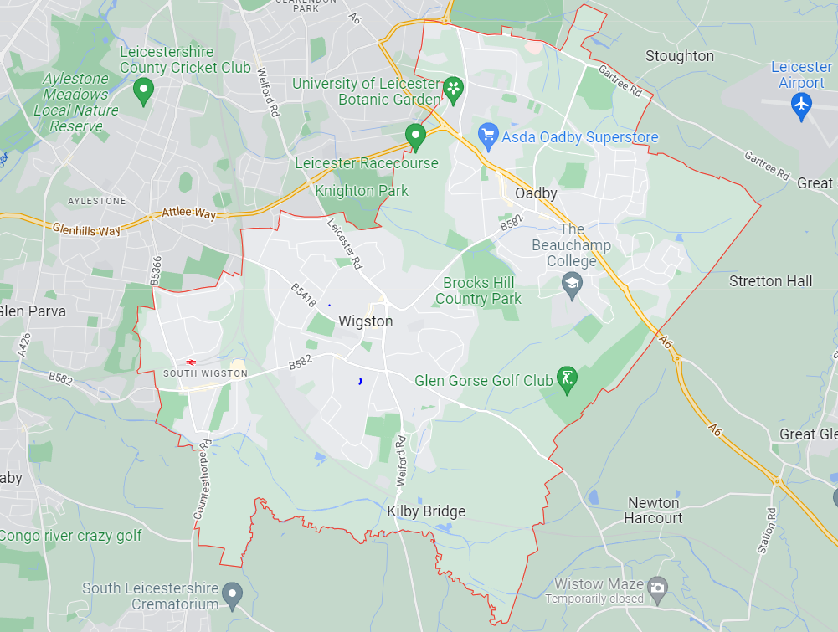
Leicester City Council
Blaby District Council
Harborough District Council
Map1.4
Map 1.3
Map 1.2
Map 1.1
Map 1.1 South Wigston - Passive NO₂ Tube Locations
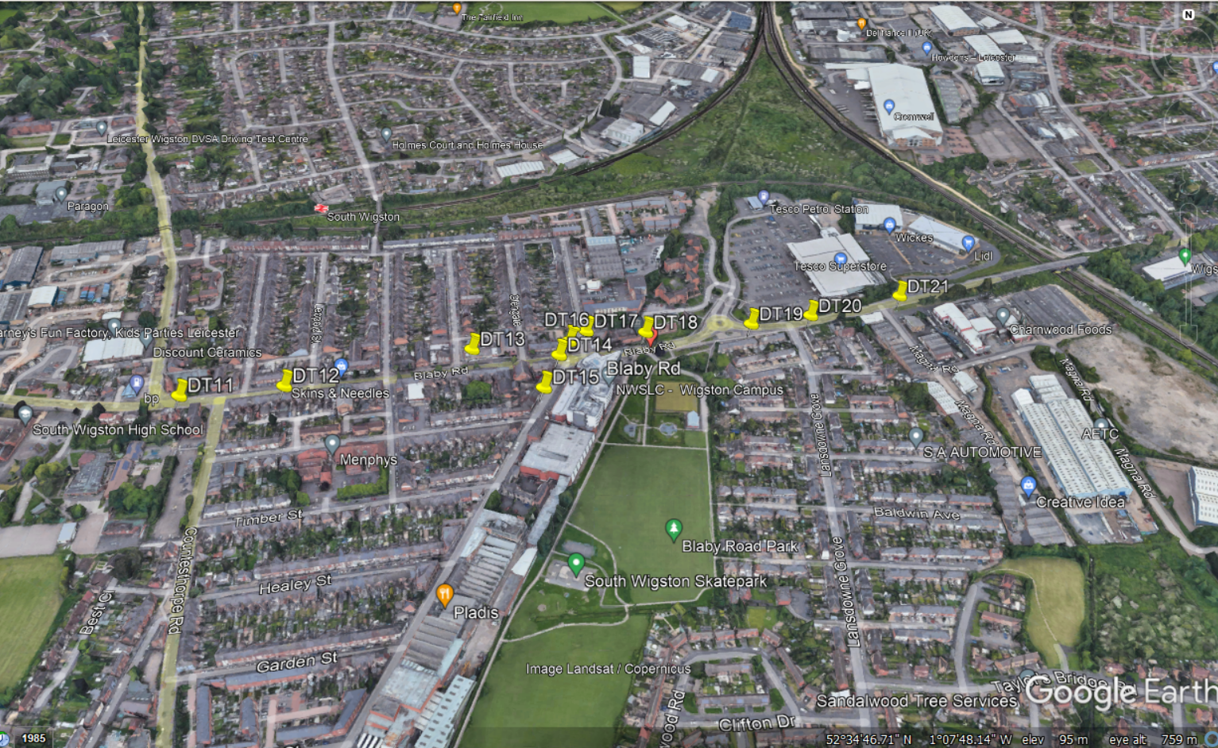
Map 1.2 Aylestone Lane - Shackerdale Road Passive NO₂ Diffusion Tube Locations
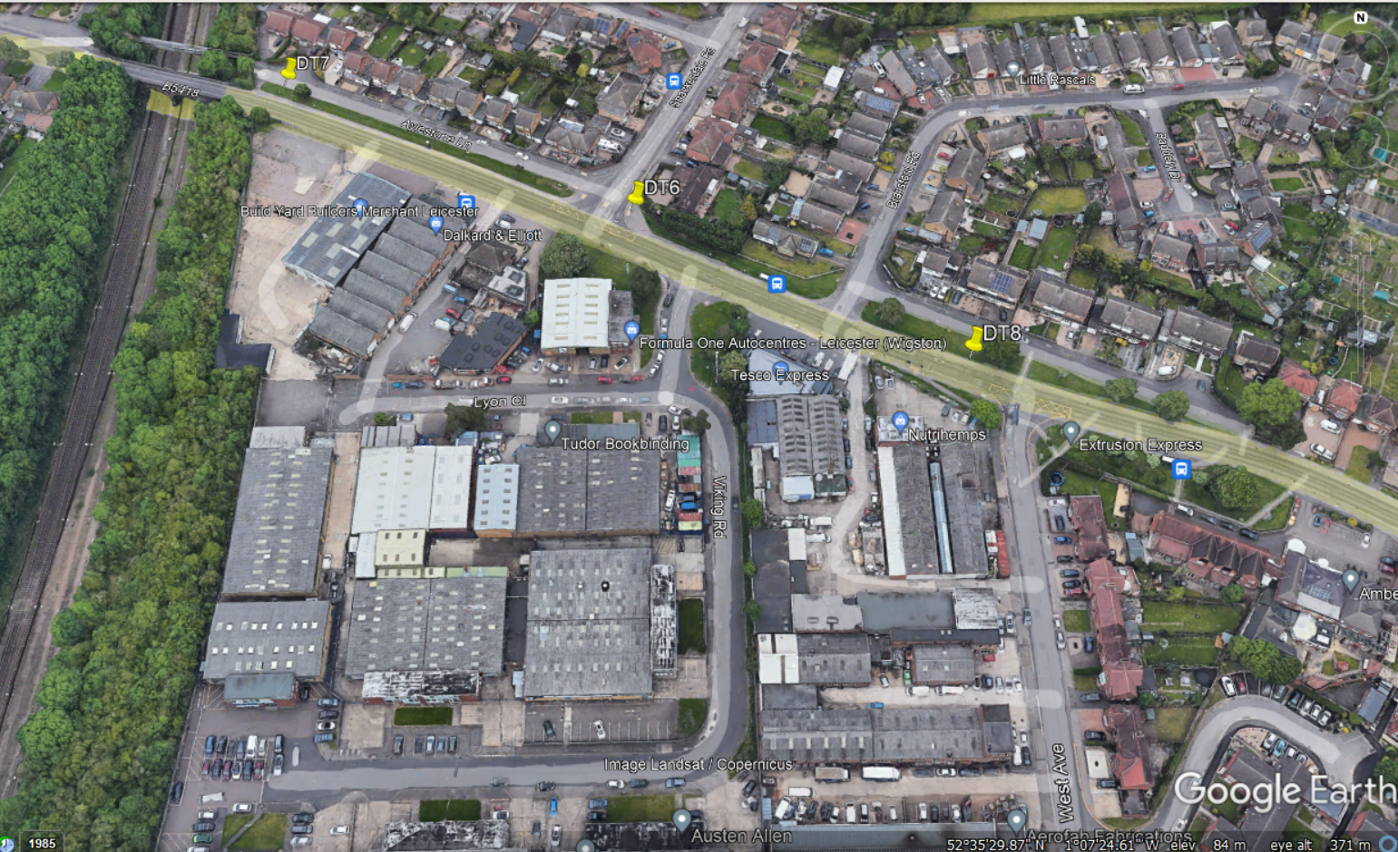
Map 1.3 Leicester Road – Bull Head Street Passive NO2 Diffusion Tube Locations
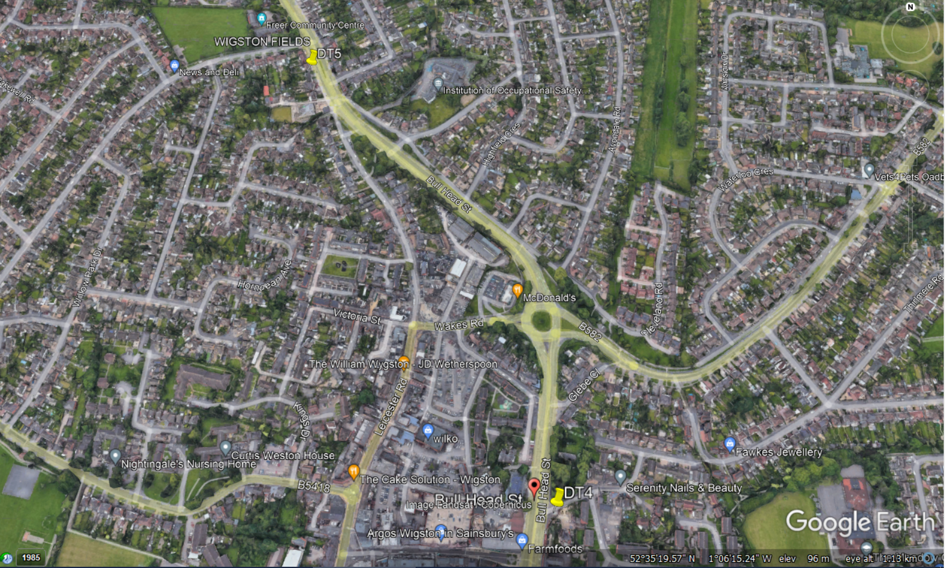
Map 1.4 A6 - Harborough Road Oadby Passive NO₂ Diffusion Tube Locations

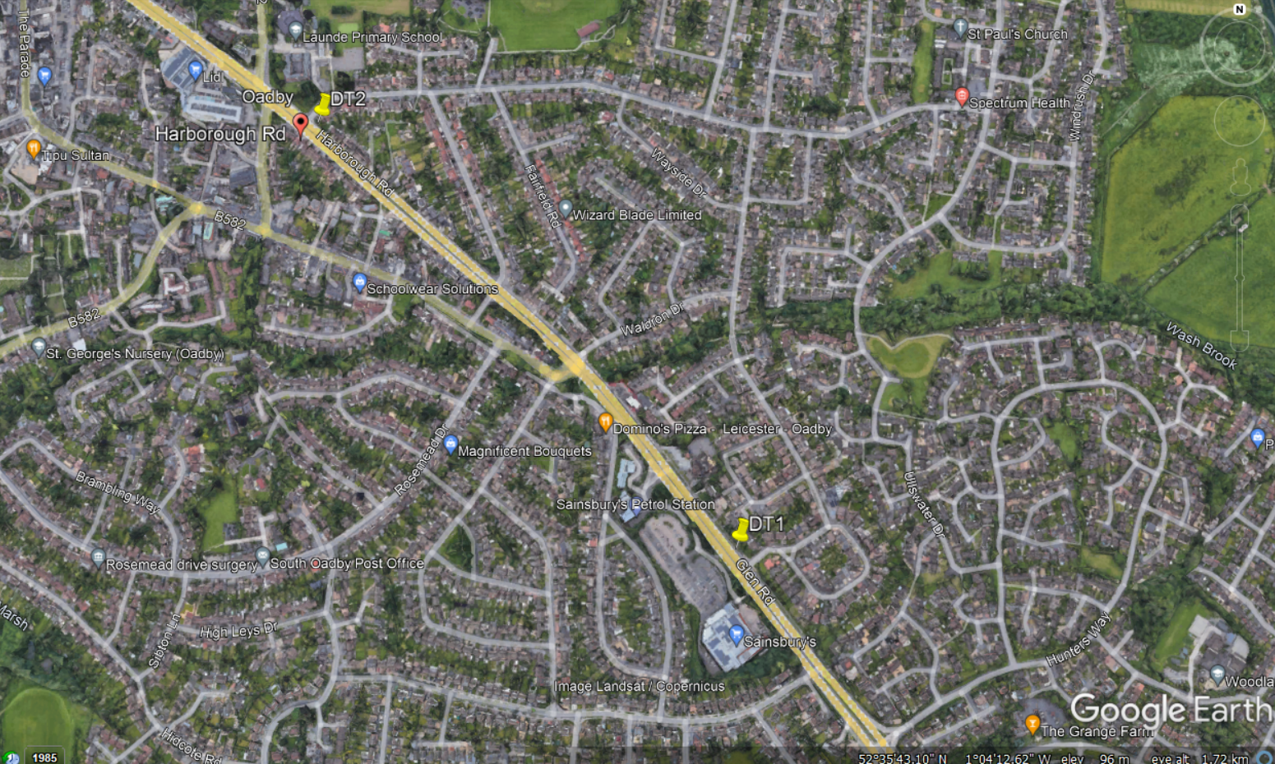
Map 1.5 A6 - Harborough Road Oadby Automatic monitoring location.
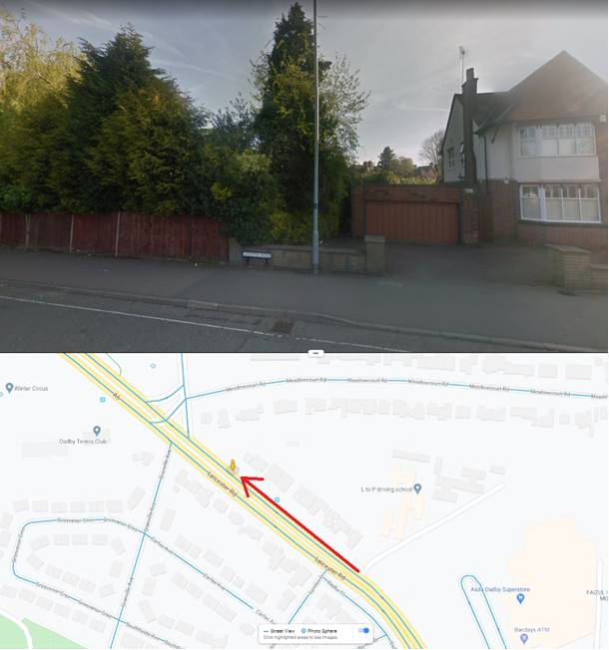

Appendix E: Summary of Air Quality Objectives in England
Table E.1 – Air Quality Objectives in England
Pollutant | Air Quality Objective: Concentration | Air Quality Objective: Measured as
Nitrogen Dioxide (NO₂) | 200µg/m³ not to be exceeded more than 18 times a year | 1-hour mean
Nitrogen Dioxide (NO₂) | 40µg/m³ | Annual mean
Particulate Matter (PM₁₀) | 50µg/m³, not to be exceeded more than 35 times a year | 24-hour mean
Particulate Matter (PM₁₀) | 40µg/m³ | Annual mean
Sulphur Dioxide (SO₂) | 350µg/m³, not to be exceeded more than 24 times a year | 1-hour mean
Sulphur Dioxide (SO₂) | 125µg/m³, not to be exceeded more than 3 times a year | 24-hour mean
Sulphur Dioxide (SO₂) | 266µg/m³, not to be exceeded more than 35 times a year | 15-minute mean

Glossary of Terms
Abbreviation | Description
AQAP | Air Quality Action Plan - A detailed description of measures, outcomes, achievement dates and implementation methods, showing how the local authority intends to achieve air quality limit values’
AQMA | Air Quality Management Area – An area where air pollutant concentrations exceed / are likely to exceed the relevant air quality objectives. AQMAs are declared for specific pollutants and objectives
ASR | Annual Status Report
Defra | Department for Environment, Food and Rural Affairs
DMRB | Design Manual for Roads and Bridges – Air quality screening tool produced by National Highways
EU | European Union
FDMS | Filter Dynamics Measurement System
LAQM | Local Air Quality Management
NO₂ | Nitrogen Dioxide
NO_{x} | Nitrogen Oxides
PM₁₀ | Airborne particulate matter with an aerodynamic diameter of 10µm or less
PM_{2.5} | Airborne particulate matter with an aerodynamic diameter of 2.5µm or less
QA/QC | Quality Assurance and Quality Control
SO₂ | Sulphur Dioxide

References
- Local Air Quality Management Technical Guidance LAQM.TG16. April 2021. Published by Defra in partnership with the Scottish Government, Welsh Assembly Government and Department of the Environment Northern Ireland.
- Local Air Quality Management Policy Guidance LAQM.PG16. May 2016. Published by Defra in partnership with the Scottish Government, Welsh Assembly Government and Department of the Environment Northern Ireland.
- Leicester City 2011-2026 LTP
- Oadby and Wigston Borough Council (2017), Updating and Screening Assessment 2017.
- Oadby and Wigston Borough Council (2018), Updating and Screening Assessment 2018.
- National Diffusion Tube Bias Adjustment Factor Spreadsheet URL http://laqm.defra.gov.uk/bias-adjustment-factors/national-bias.html
- Report used to confirm WASP/AIR PT scheme information on SOCOTEC, URL Address: https://laqm.defra.gov.uk/assets/laqmno2performancedatauptonovember2019v1.pdf
- Summary of Precision Results for Nitrogen Dioxide Diffusion Tube Collocation Studies, by Laboratory, URL Address: https://laqm.defra.gov.uk/assets/tubeprecision2018version0619finalreduced.pdf
- Oadby and Wigston Borough Council Local Plan 2011 – 2031 (adopted 2019)
https://www.oadby-wigston.gov.uk/pages/new_local_plan
- Health and Air Quality Partnership action plan https://politics.leics.gov.uk/documents/s155032/Appendix%20-%20Air%20Quality%20Action%20Plan.pdf

Public Health England. Air Quality: A Briefing for Directors of Public Health, 2017
Defra. Air quality and social deprivation in the UK: an environmental inequalities analysis, 2006
Defra. Air quality appraisal: damage cost guidance, July 2021
Public Health England. Estimation of costs to the NHS and social care due to the health impacts of air pollution: summary report, May 2018
Defra. Clean Air Strategy, 2019
DfT. The Road to Zero: Next steps towards cleaner road transport and delivering our Industrial Strategy, July 2018
https://laqm.defra.gov.uk/assets/laqmno2performancedatauptonovember2019v1.pdf
The units are in microgrammes of pollutant per cubic metre of air (µg/m³).

