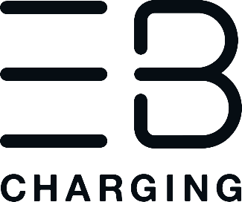
USE OF ELECTRIC BLUE FAST CHARGERS

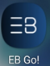
Oadby and Wigston residents, businesses and visitors can now charge their EV (Electric Vehicle) in a number of public locations, with fast chargers installed in car parks at Aylestone Lane, Wigston, East Street, Oadby and Wigston Pool and Fitness Centre, Wigston.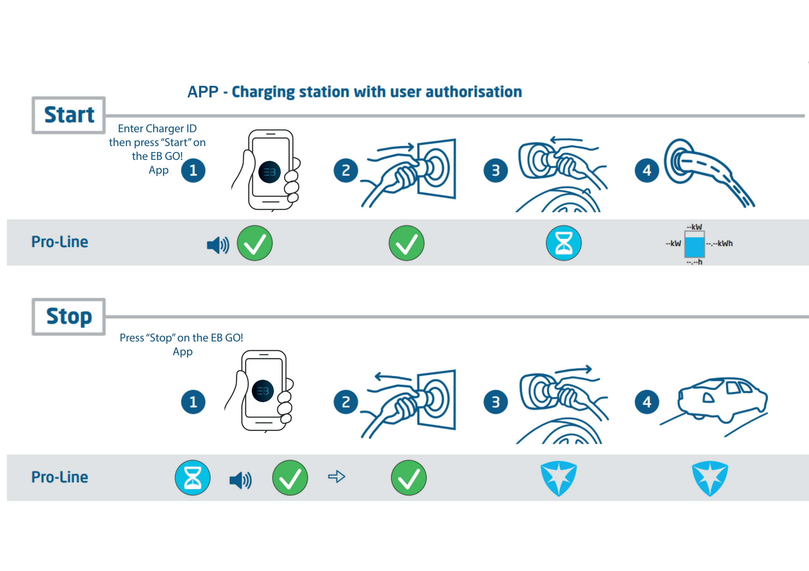Charging is simple, and within an hour the 7kW Alfen chargers can provide your EV with 20-30 miles of range. First, you will need to download the EB Go! Charging application - this app is available for iOS and Android smartphones, and does not ask for a membership fee or minimum spend.

The app will display the nearest charger to you, as well as whether it is in use or not. You can then use the app to enter the charger’s ID, or scan its QR code. If you are using the app for the first time (you can charge as a guest), you will have to enter your payment details, while returning users confirm their payment method and pass a security check.

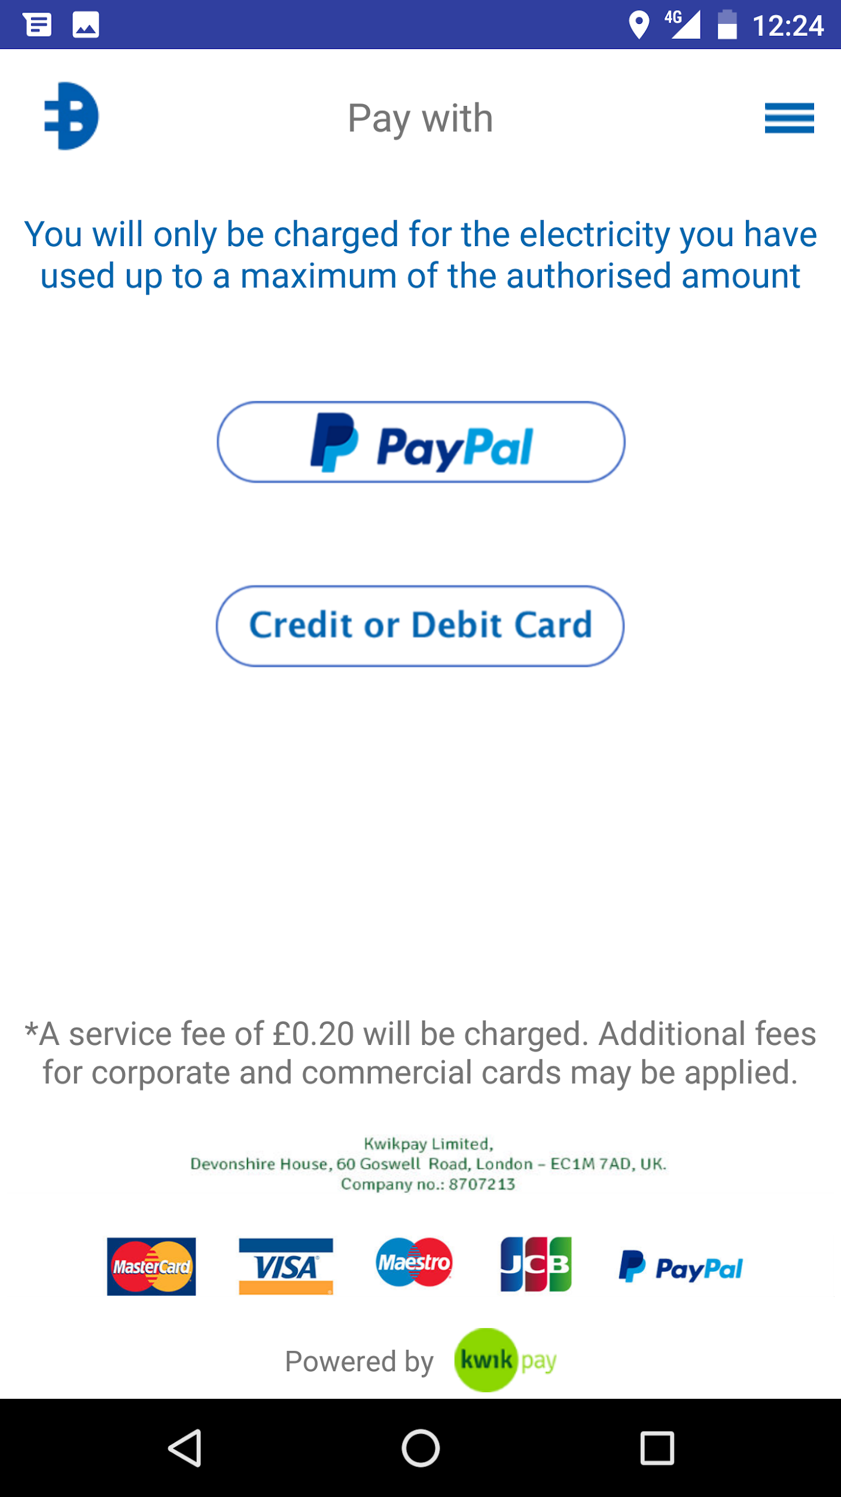
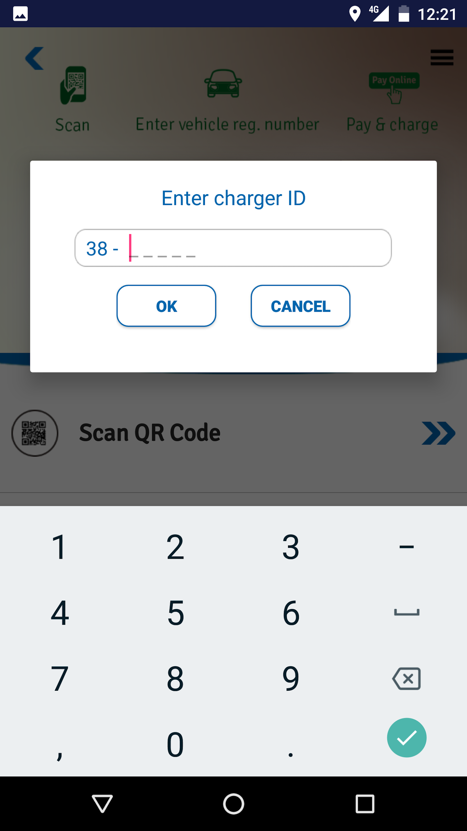

Once you have paid, all you need to do is “Plug and Play” - plug in the connector, press “Start Charge” on the app, and the charging event will begin. You will be able to see the cost of the charge, the kWh of power drawn and the battery percentage of your vehicle via the app.

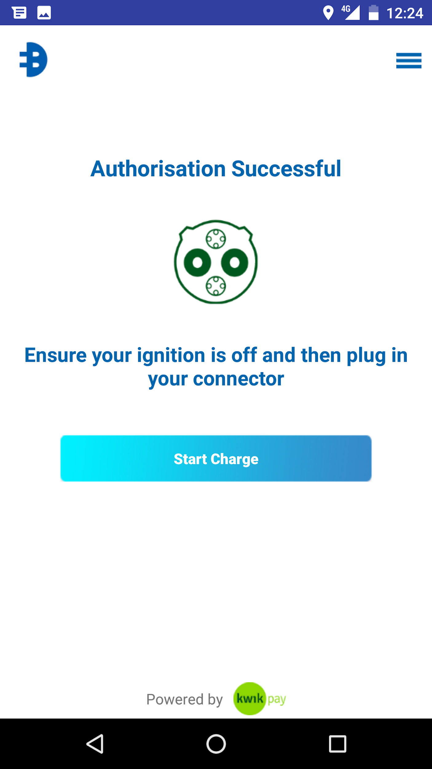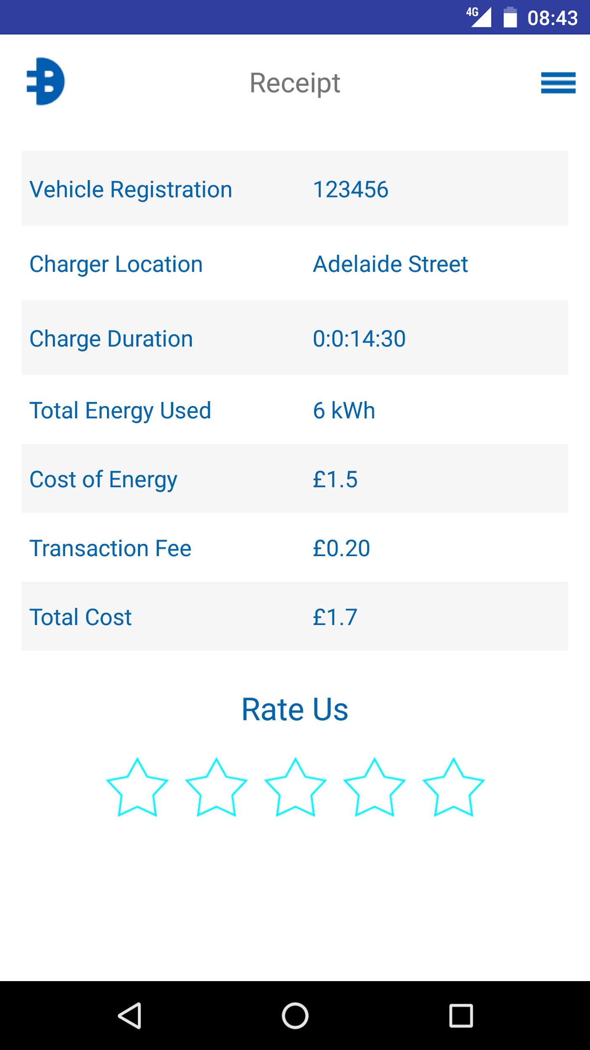

Once you’ve finished charging or need to go, just press “Stop Charge”, disconnect the plug and continue your journey!
