FORM 4A

Medium scale development (commercial) between 500m² & 999m² Heritage/Arboricultural Advice

If you require assistance, please telephone (0116) 2888 961 or email planning@oadby-wigston.gov.uk.

Please read and tick one of the following options. We will be unable to accept your application without this.

☐I consent for my data to be processed and stored in accordance with the Data Protection Act 2018, I understand that the information submitted on this form may be made publicly available or shared with third-parties as necessary (we will never share your information for marketing purposes).

☐I DO NOT want my data to be made publicly available and have provided the following reason(s) for wanting my application kept confidential:
_____________________________________________________________________________________________________________________________________________________________________________________________________________________________________________________________________________________________________________________________________________________________________________
Please note that if a Freedom of Information or Environmental Information Regulations Request is received that involves the site(s) listed on the application, Oadby and Wigston Borough Council will have the final decision over whether the data provided can and/or will be released. We will always endeavour to take into account the reason(s) you have listed above.

Please ensure that the correct fee has been paid and you complete this form in full (relevant parts) and return it to:

Planning Control
Oadby & Wigston Borough Council
Brocks Hill Council Offices
Washbrook Lane
Oadby
Leicester
LE2 5JJ

Or via email to planning@oadby-wigston.gov.uk

Please note that the enquiry will not be assessed until the correct fee has been received

Contact details

Contact Name:

Contact Address:

Post Code:

Contact Telephone No:

Contact Email Address:

Proposal Details
Site Address to which this enquiry relates:

Full Description of proposed works (The more details provided the more informed the response will be):

Length: Metres

Height to Eaves: Metres

Width: Metres

Height to ridge (or highest roof point): (Metres)

Is the proposed work an extension to the existing building? Yes/ No

If Yes, please state the type of extension (kitchen, bathroom, etc):

Are there to be any internal alterations? Yes / No

If Yes, please give a brief description:

Distance of proposed work to nearest boundary: Metres
Will you be making an application or a grant from this Council? Yes / No

Previous History

Have any previous extensions/buildings been erected at the property since it was originally built? (Including any garages, carports or outbuildings within 5 metres of the main building or any dormer windows inserted): Yes / No

If Yes, please give details of the work previously carried out:

Length: Metres

Height to Eaves: Metres

Width: Metres

Height to ridge (or highest roof point): Metres

When was the work carried out?

Vehicle Access & Demolition Details
Will the development require alterations to (or a new) vehicle access? Yes / No

If Yes, will the proposed access be: New private drive / New road

Does the proposal require the demolition of any existing buildings? Yes / No

If Yes, please give details:

Please attach a detailed sketch plan showing the position of the proposed development in relation to the property, adjacent properties and the highway (see example below)
If you include dimensions, please make them metric.
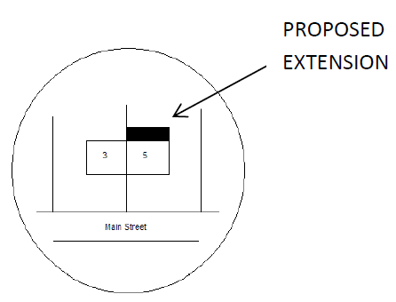

Fee Required: £1,000 (Please note that if both heritage and arboricultural advice is required an additional £100 charge will apply).

Fee Paid:

Date Fee Paid:

Receipt No:

Payment Method: Telephone Payment / Bank Payment / Cheque

Please attach any additional information you feel may assist us in dealing with your enquiry

Signature:

Date:

