Café Operator Opportunity

Brocks Hill Country Park, Washbrook Lane, Oadby, Leicester LE2 5JJ

Information Pack

March 2023

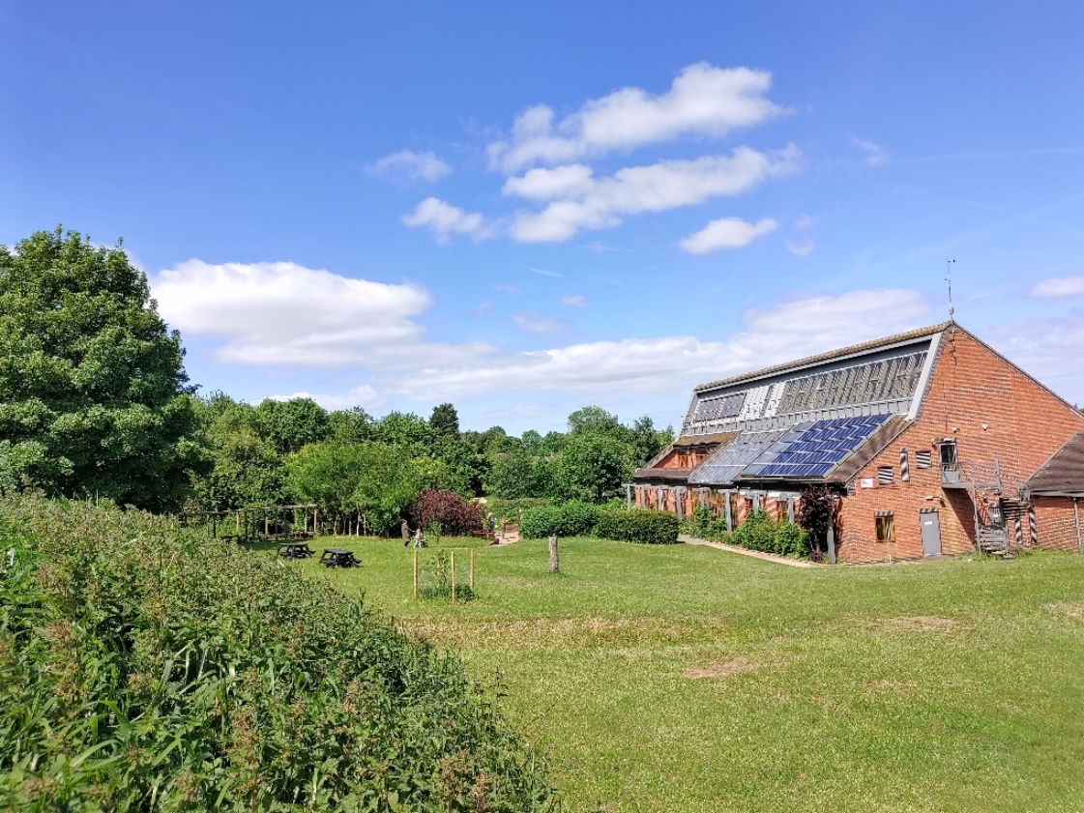

THIS DOES NOT COMMIT THE COUNCIL TO A FUTURE PROCUREMENT EXERCISE OR CONTRACT.
Please note all information provided in this document is indicative and for information purposes only. All responses will be treated with confidentiality.

Brocks Hill Country Park – Café Operator Opportunity
Expressions of interest are sought for a lease opportunity for a Café within the fully refurbished building located at the entrance to the Brocks Hill Country Park.
The full site consists of the walkable award winning Country Park, newly refurbished Council Offices (Where the Café is situated) and Parklands Leisure Centre.
The Café, that has been on the site since approximately 1999, was previously operated by our leisure partners, Everyone Active. The Café has temporarily been closed due to refurbishment works of the entire building (that are set to complete early Summer) and there is now an exciting opportunity for a new Café operator to reopen the Café for use following the interim closure.

Oadby and Wigston Borough Council is seeking expressions of interest in the leasing of the Café area and associated toilet facilities.

Consideration:
The Council will consider tenders for a fixed rent or a turnover rent.

Operational Hours:
The Council would like the prospective service provider to cover:
Monday: 07:00AM – 6:00PM
Tuesday: 07:00AM – 6:00PM
Wednesday: 07:00AM – 6:00PM
Thursday: 07:00AM – 6:00PM
Friday: 07:00AM – 6:00PM
Saturday: 9:00AM – 4:00PM (Maximum hours allowed)
Sunday: 9:00AM – 4:00PM (Maximum hours allowed)
Bank holidays: 9:00AM – 4:00PM (Maximum hours allowed)

Collaboration:
The council work in partnership with other external groups and organizations that permanently or temporarily reside on the overall site, including 3rd parties using the park for events and shows, and it is essential that the prospective Cafe provider joins this partnership and offer new ideas of how the venue & site can be developed and improved.

Customer Service
Excellent customer service is a main priority of the council, and we expect this to be upheld by the café operator. They must share the Councils values and both the Council and Operator will work in conjunction to ensure the best service is offered by both parties.

Brocks Hill Country Park:
Site size: 67 Acre Country Park
Amount of users per year: Approximately 200,000
Ample parking for its users, with an overflow car park to accommodate busy periods – please note the car park is shared with users of Parklands Leisure Centre.
The Park has been awarded the ‘Gleen Flag’ award for 15 consecutive years
The park has events 7 days a week and includes things like:
- A permanent Orienteering course
- Themed trails
- A human sundial
- Environmental art in the form of sculptures
- A dedicated den building area

The park also has two play areas suitable for all ages with seating

The park has numerous volunteer groups who support and help with the managing of the areas with the Councils Park Wardens

Users of the park are keen dog walkers and nature enthusiasts. The park has ponds, meadows, hedges, and woodlands where there is an array of wildlife for users to see and hear.

There is also an amphitheatre that is used for events, shows and is something that draws crowds in the summer time.
More information relating to the Country Park can be found here:
https://www.oadby-wigston.gov.uk/pages/brocks_hill

Vision for Brocks Hill
The site has been fully renovated and the park is attracting more users than ever before. There will also be an increased use of the area by approximately 50 people per day following the relocation of the Councils workforce to the site/building in the Early Summer.
We are always seeking opportunities to utilise the site as much as possible with ticketed events, family events, volunteering groups, Orienteering courses, etc, and the new provider will be able to work with the Council on these type of increased footfall events to maximise the Café usage.
We are seeking to engage a service provider that will offer a relatively modern café/coffee shop experience in the setting of our beautiful country park. It must have inside seating and must offer hot and cold beverages and food.
Where possible, the café should provide a menu of fresh, tasty, food at realistic prices, including hot and cold drinks, light lunches, cakes and afternoon tea. Locally sourced ingredients are encouraged and we would like to understand your environmentally friendly credentials.
It is possible, that the Council may need the service to provide catering for meetings, group tours and small events that are on the site. There are rooms (within the rest of the building that you will not manage) that are for Council functions, training, large public meetings and other events now things are back to normal following the Covid-19 Pandemic.

Direction To Brocks Hill
On foot:
The centre is located 10 minutes walk from Oadby Town Centre, 20 minutes walk from Asda Store, Oadby and 40 minutes walk from Wigston
From Wigston
Head west along the B582, Wigston Road to its signalized junction with Brabazon Road. Turn left into Washbrook Lane. Follow this road past the Parklands Leisure Centre to the Centre building beyond.
From Oadby
Head east along the B582, Oadby Road leading to Wigston Road. Turn left into Washbrook Lane. Follow this road past the Parklands Leisure Centre to the Centre building beyond.
By bus
The number 31A bus from Leicester passes Leicester Railway Station and will stop on Brabazon Road which is a short walk away from the centre. The number 31 bus from Leicester passes Leicester Railway Station but you would need to walk from Oadby Town Centre - about 15 minutes. The number 40 bus runs from Wigston Magna to Oadby and will stop on the B582 Wigston Road which is a short walk away from the Centre.
By train
Leicester Railway Station is approximately four miles from Brocks Hill Country Park and Centre and is served by regular buses and taxis. South Wigston station is approximately three miles away.

By road
Post code: LE2 5JJ

From Leicester
- Take the A6, London Road out of Leicester city centre (passed the railway station) and straight on at the Victoria Park roundabout.
- Remain on the A6, London Road and head south following signs to Oadby and to Leicester Racecourse until you arrive at the roundabout junction with the A563, Palmerston Way.
- Take the first exit and continue on the A6 towards Oadby.
- After the first set of traffic signals move into the right hand lane.
- At the second set of traffic signals (Asda), turn right into Brabazon Road.
- Remain on Brabazon Road to the traffic signal junction and continue straight over into Washbrook Lane.
- Continue past Parklands Leisure Centre car park and into the Brocks Hill Visitor Centre Car Park.

Facilities & Features
The Café area highlighted in the attached plan, will be provided to you as an empty space. There will be electrical outlets supplied at the points marked on the plan. However, furniture will not be provided, any furniture on the plan is for indicative purposes only.
There is 1 external door that will be the main entrance and exit for the Café users. There will be toilets for male and female and there will also be an internal door that will take customers through to the Councils main reception area. There is also an emergency fire exit to the rear near the public toilets.
Air conditioning, lighting and fixtures and fittings are provided. Power consumption will be charged back to the tenant at the rate the Council is charged from its provider (via a tenants metered distribution board).
The winning bidder will need to supply furniture and the equipment to run the café including any ovens, microwaves, coffee machines, refrigerators, etc. You will also be responsible for the cleaning of all café areas, including the public toilets.
The Council will not provide any internet, WIFI, phone or local network to the operator.
Please note the following fit out details:
- A cold water only feed at high level via a 15mm copper pipe.
- Electrical supply will be via a tenants metered distribution board in the exterior adjacent corridor.
- A stainless steel drainer sink is retained with connected waste to existing drainage.
- A newly fitted window mounted electric extract fan.
- A serviced and cleaned stainless steel cooker range extract / grease trap.
- Newly fitted fire resistant doors.
- Altro type anti-slip welded floor covering.
- A servery counter is provided with a laminate top.
- The servery floor is fitted with Altro type anti-slip welded floor covering.
- The back of servery wall is fitted with white laminate hygienic board.
- There will be no white goods provided within the Client fit-out.

Following a completed expression of interest form, interested parties will be invited for a site visit.
Appendix: Ground floor plan
Appendix: Electrical power plan

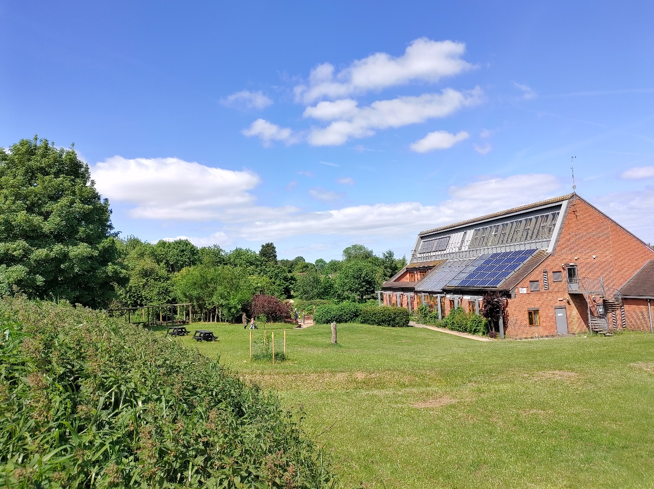

Summary
Expressions of interest are sought for a Café Operator within the newly refurbished Brocks Hill Country Park Building in Oadby.
Interested parties are invited to informally discuss the matter with The Council’s Project Manager, Ben Wilson, by emailing ben.wilson@oadby-wigston.gov.uk who can advise further.

Expressions Of Interest
Written expressions of interest using the enclosed ‘Expression of interest form’ should be sent by 12 noon on Monday 20th March 2023 by e-mail to:
Ben Wilson – Corporate Project, Systems & IT Manager - Ben.Wilson@oadby-wigston.gov.uk

Next Steps
Following receipt of the Expressions of interest, suitable applicants will then be contacted to formally tender for the offering.
Proposed Timeline:
- 20th March – Expression of interest deadline
- WC 27th March – Site visit
- 27th March – Official Bid process begin (for 2 weeks)
- 10th April – Bid response deadline
- 14th April– Operator Awarded
- Late April / Early May: Contract signing and Preparation
- June: Official opening.

Appendix / Document List:
Appendix: Expression Of interest Form
Appendix: Location Plan
Appendix: Ground Floor Plan
Appendix: Electrical power & BMS plan

