**South Wigston Shop Front Improvement Grant Scheme**

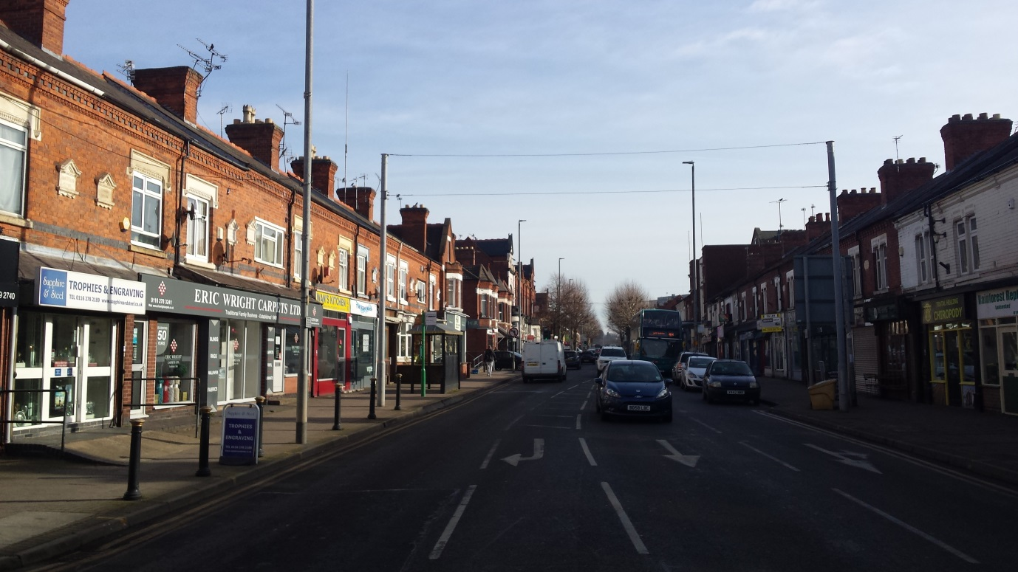

**This project is funded by Oadby and Wigston Borough Council**

**Applicant Details:**

|  |  |
| --- | --- |
| Contact name: |  |
| Contact address: |  |
| Name of business: |  |
| Business address (if different to above): |  |
| Contact telephone number: |  |
| Contact email address: |  |
| Website: |  |
| Nature of business: |  |

Is your business VAT registered? Yes/ No

Your interest in the property:

* Owner
* Tenant
* Other (please specify) ____________________

If you are a tenant please give number of years remaining on your lease: ______________________

Have you made any previous applications for grants for improvements to the premises?

Yes/ No

If yes please give details:______________________________________________________________

__________________________________________________________________________________

__________________________________________________________________________________

__________________________________________________________________________________

**Important information:**

Under European “State Aid” rules your business should not obtain more than a total of 100,000 euro’s (approx. £85,000) from other Government Departments of local authorities over a 3 year period.

I have read the above and confirm that we have not received any recent state aid, as above (please tick) 🞎

**Statement of Works:**

Please describe the changes that you propose to make including:

* Reference to whether doors, windows or entrances are to change
* The nature of changes to frontage façade including details of features you wish to add or remove
* Changes to retail display units
* Details of colours and styles to be employed

|  |  |
| --- | --- |
| **Description of works:** | **Costs:** |
|  |  |
|  |  |
|  |  |
|  |  |
|  |  |
|  |  |
|  |  |
|  |  |
|  | **TOTAL:** |

Are the costs (please tick):

Estimated 🞎

Based on a quote 🞎

What is your expected start date for the work? _______________________________________

When do you expect the work to be completed? ______________________________________

Do you require any of the following permissions? (Please tick relevant box):

|  |  |  |
| --- | --- | --- |
|  | YES | NO |
| Planning permission |  |  |
| Building control approval |  |  |
| Listed building consent |  |  |
| Advertising consent |  |  |

“Please note that any planning permissions, approvals or consents are the responsibility of the business and need to be acquired from Oadby and Wigston Borough Council (“the Council”) as the Local Planning Authority prior to the approval of any separate decision by the Council in respect of the bid request.”

**Declaration**

I / We hereby declare that I / we have read the terms and conditions and declare that the information given within this application form and any supporting material is correct to the best of my / our knowledge. I authorise Oadby and Wigston Borough Council to make any inquiries it considers necessary for the assessment of the application.

Signature: ______________________________________________________________________

Print name: _____________________________________________________________________

Position: _______________________________________________________________________

Date: _______________________

Please check that you have enclosed the following before sending:

* Copy of tenancy (if tenant) or the application has been countersigned by the owner of the property
* Photographs showing the current front and side elevations of your shop/business front
* Visuals on proposed alterations (if available)
* VAT declaration

Please return this form accompanied by all relevant paperwork to Jeffery Kenyon (Economic Regeneration Manager).

Jeffery Kenyon

Economic Regeneration Manager

Oadby and Wigston Borough Council

Council Offices

Station Road, Wigston

Leicestershire, LE18 2DR

Email: [Jeffery.Kenyon@oadby-wigston.gov.uk](mailto:Jeffery.Kenyon@oadby-wigston.gov.uk)

“The data provided within this form will be used for the purpose of this request and we will not use the data for any other purpose. We may, where necessary, share your data with another department or with a third party organisation for the purpose of providing you with the service that has been requested. Full details of to whom and to where we may send data can be found on our website at: [www.oadby-wigston.gov.uk/pages/privacy](http://www.oadby-wigston.gov.uk/pages/privacy).”